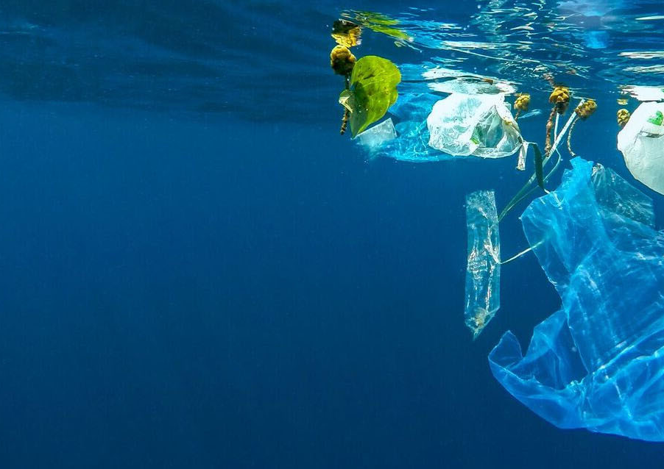
Draft Proposal for the Development of Tools to Address Tourism based Marine Litter and Solid Waste in the Caribbean
A study on a selection of countries in the Caribbean
Dec 2021

Prepared by:
Mr. Ronald Roach
and Katrina Khan-Roberts
Under the guidance of:
Gulf and Caribbean Fisheries Institute

In Collaboration with:
Caribbean Tourism Organization.
Date:
12th December 2021
Original Text:
English

Suggested Citation:
Gulf and Caribbean Fisheries Institute (2021). “Tourism based Marine Litter and Solid Waste Assessment and Toolkit for the Caribbean.”
Photography Credits:
© UNEP Marine Litter the Issue https://www.unep.org/fr/node/1377

LIST OF ACRONYMS AND ABBREVIATIONS
CEC Certificate of Environmental Clearance
CDRM Comprehensive Disaster Risk Management
DRR Disaster Risk Reduction
EIA Environmental Impact Assessment
EMA Environmental Management Authority
GORTT Government of the Republic of Trinidad and Tobago
M&E Monitoring and Evaluation
MEA Multilateral Environmental Agreements
MEAU Multilateral Environmental Agreements Unit
MERIL Monitoring Evaluation Reporting Improvement and Learning
MRV Monitoring Review and Verification
NDA National Designated Authority
NDC Nationally Determined Contributions
NEP National Environmental Policy
RBM Results Based Management
SIDS Small Island Developing States
UN SDGs United Nations Sustainable Development Goals/ 2030 Agenda for Sustainable Development.
VCA Vulnerability and Capacity Assessment

EXECUTIVE SUMMARY
Marine litter and solid waste plague most SIDS, however in the case of the Caribbean the impact of waste derived from the tourism industry is very significant. This can be broadly discussed as waste generated by tourism products such as cruise ships, tourist attractions and tour guides as well as the tourist themselves and their interaction with the destination. The destination must be equipped to handle waste for its own population and then be able to manage waste from other sources. It is difficult to attain accurate data on waste generation in most Caribbean countries, far less data specific to tourism generated waste. The best estimates are grossly inaccurate. With the COVID-19 pandemic, the process to retrieve information is even more difficult, though the global halt in travel could have had great potential for destinations to put the necessary systems in place to manage tourism generated wastes.
The overall processes identified for each destination are as follows:
- Legislation, Policy and Guidelines
- Agencies
- Facilities and infrastructure
- Education
- Civil Society Action
- Public Compliance
- Review and Monitoring

In order to reduce the waste generated by tourists to a destination and in turn reduce the environmental impact on these vulnerable SIDS, complete overhauls of waste management structures must be done. All aspects of the government are intertwined in waste generation and management and all waste has the potential to impact the marine environment. The opportunity to do better exists in each individual territory, but more research is needed to inform legislative change, especially in tourism.
In summation, sustainable development begins with understanding consumption and the fulfilment of the needs of the population. Once options are accessible and feasible, the public will make the most appropriate choices and abide by rules and regulations. It is up to all levels of society to work together for the common goal of protecting our shared environmental resources.
This proposal is for the development of educational and capacity building tools for the improvement waste management activities undertaken by tourism stakeholders.

Contents
LIST OF ACRONYMS AND ABBREVIATIONS 3
EXECUTIVE SUMMARY 4
1. Introduction 7
2. Preliminary Survey 10
3. Results and Assessment 14
4. Strategic Action Plan 16
5. Regional Best Practices 17
6. Regional Stakeholders 21
7. SWOT Analysis and Gap Analysis 22
8. Proposed Activities, Toolkits and Resources 24
9. Budget 27
10. References 28
Appendix 1 – Survey Tool 29
Appendix 2 – Stakeholder Listing 37
Appendix 3 – Waste Toolkit 44
Appendix 4 – Strategic Action Plan 53
Appendix 5 – Country Fact Sheets 56
Antigua & Barbuda Fact Sheet – Solid Waste Management 57
Bahamas Fact Sheet – Solid Waste Management 60
Barbados Fact Sheet – Solid Waste Management 62
Cuba Fact Sheet – Solid Waste Management 64
Dominica Fact Sheet – Solid Waste Management 66
Dominican Republic Fact Sheet – Solid Waste Management 67
Grenada Fact Sheet – Solid Waste Management 69
Haiti Fact Sheet – Solid Waste Management 72
Jamaica Fact Sheet – Solid Waste Management 73
Martinique Fact Sheet – Solid Waste Management 75
Saint Lucia Fact Sheet – Solid Waste Management 76
Saint Kitts and Nevis Fact Sheet – Solid Waste Management 78
Saint Vincent and the Grenadines Fact Sheet – Solid Waste Management 80
Sint Maarten Fact Sheet – Solid Waste Management 82
Trinidad and Tobago Fact Sheet – Solid Waste Management 84

- Introduction
Solid waste management is a basic need of communities. In the modern world, conveniences and sanitation have led to previously unseen types and quantities of waste being generated. Access to clean drinking water, shelter, food, energy, transport and communications are essential to society, and managing solid waste in a sustainable manner is essential to human and environmental health and sustainability. Tourism, while an economic earner, also generates large quantities of different types of waste. These come from consumables such as food and drink but also through packaging of non food items such as souvenirs and other goods and services. In tourism dependent nations such as in the Caribbean, the SIDS and countries with large stretches of coastline most acutely see marine litter as an issue. The relationship between tourism and marine litter in this region is one that requires deeper research and the implementation of controls.
The document presents a proposal to cover three main areas related to improved marine litter management across the countries of the Caribbean, as follows:
- Online training (the development of a toolkit and integration of other resources available),
- Support and sustainable development of Small and Medium Sized Enterprises (SMEs),
- Updating of existing toolkits relating to waste and plastics management by the Tourism sector.
It will focus on:
- Replicating/Up scaling Regional Best Practices and responding to Gaps and Needs identified,
- Updating/Refining existing toolkits and other resources,
- Implementing a comprehensive training programme including sensitisation,
- Stakeholder Engagement.
The supporting information included in this proposal is as follows:
- Preliminary Survey - Regional Survey to assess tourism stakeholders understanding of waste management to identify the gaps, needs and priorities of the tourism public, private and community stakeholders prioritising Small and Medium Sized Enterprises (SMEs),
- Outline of a Strategic Action Plan - Inter alia strategic action plan with recommendations for areas for strategic interventions,
- Summary of regional Best Practices,
- Gap Analysis and Needs,
- Summary of existing regional toolkits and resources - Analysing toolkits and other resources as well as opportunities for updating resources and for training and sensitisation,
- List of major regional stakeholders - Identifying key stakeholders and partners for collaboration,
- Detailed Budget - detailed costing for recommended activities.

For the purposes of this proposal, the following countries were analysed:
- Antigua and Barbuda
- Bahamas
- Barbados
- Cuba
- Dominica
- Dominican Republic
- Grenada
- Haiti
- Jamaica
- Martinique
- Saint Lucia
- Saint Kitts and Nevis
- Saint Vincent and the Grenadines
- Sint Maarten
- Trinidad and Tobago
Internationally, there are existing mechanisms and legislation that address the discharge of waste and plastic in the sea. The International Convention for the Prevention of Pollution from Ships (MARPOL) aims to prevent pollution from ships by prohibiting ships from discharging plastic into the sea and requiring governments to ensure adequate port reception facilities to receive ship waste. The Convention on the Prevention of Marine Pollution by Dumping of Wastes and Other Matter (London Convention and Protocol) regulates what materials can be dumped at sea and what materials are not permitted. The Action Plan will be regularly reviewed and updated as necessary. The MEPC adopted the action plan at its 73rd session that convened in London, UK, from 22-26 October 2018 (IISD, 2021).
The Caribbean region relies heavily on its natural assets as sources of income, generally for tourism and in particular cases from agriculture and energy, environmental taxes in the region exist to protect against exploitation. Vulnerabilities in SIDS have been vastly explored. The evolution of the vulnerability score over time can provide important signals about the changing productive and export structure of a country, such as competitiveness in international markets for example. The inherent characteristics that make governments vulnerable and how this has evolved over time is complex (CDB, 2019). Adequate solid waste management is a particularly sensitive issue for the Caribbean countries, since their economies are mainly natural resource-based, with tourism, mining, agriculture and fisheries being the dominant sectors. Riquelme (2016) identifies solid waste environmental impacts on public health and natural resources. These are the risks of disease with regard to vermin and the proliferation of bacteria and other illness causing actors.
It is critical to raise awareness of the negative environmental and economic effects of marine litter in the marine environment, including effects of “ghost fishing” of lost or discarded fishing gear. Marine litter affects sea animals and their ecosystems, but it can also be a risk for human health and safety and impact the economy of those areas depending on tourism. Marine litter from tourism sources is a complex issue in the Caribbean region. It is difficult to firstly find point sources of litter on islands that are bounded by the sea on all sides where litter can be coming from other locations, riding currents and waves from any part of the globe. It is also difficult to identify point sources within the same country as there is potential litter coming from the public as well as tourism based generation that may overlap, for example from food services and other highly consumable products in persistent packaging.
Much of this is tied to small businesses that develop in an ad hoc manner within destinations. For example, a popular beach would have facilities for food and drink, restrooms and change rooms, parking as well as gift and beach supply shops. The wastes generated can then be seen as packaging (papers, Tetra packs, plastics, glass and cans); food related including organic food waste, sewage, grey water and even air pollution from exhausts and cooking implements. Tourists, including foreign and domestic, are responsible for the bulk of this waste, however the operators have a part to play as the providers of the goods and services being consumed at the destination, and by and large the government of the destination has overall control of the legislation, policies and guidelines paving the way for these activities. For the purposes of this proposal we will be focusing on solid waste that can potentially become marine litter. The onus is on all stakeholders at each destination to ensure that solid waste is managed not only for the preservation of the tourism product but the intrinsic value of the environment itself.

- Preliminary Survey
Waste and waste management are a key primary indicator for environmental sustainability in tourism. In order to guide the proposal of a strategic action plan and a toolkit, a snapshot of the Caribbean countries and their intricate solid waste management systems was firstly required. Information was derived from sources such as government web pages and available legislation in each territory and can be found in the appendices as country specific fact sheets. The vast differences in government types and structures as well as location specifications, both physical and managerial, led to firstly a targeted data gathering methodology and secondly an assimilation to find similarities and differences which could feed into common gaps and recommendations.
A questionnaire was then formulated in order to capture data from stakeholders in each location, ranging from government and policy makers to state agencies and private companies to civil society. A cross-section of the stakeholders from each territory was critical to survey in order for the most representative sample to be derived. The questionnaire was delivered via Google Forms (Appendix 1). The survey was conducted from November 22nd to 30th and sent to 60 stakeholders with 6 responses (3 from Barbados, 2 from Trinidad and 1 from Saint Lucia). With more time it is estimated that the response rate would have been higher. Further data collection must be implemented in order to get a more representative dataset. The following represents a snapshot of the information garnered from the survey. The snapshot of the responses received are provided in the figures below.
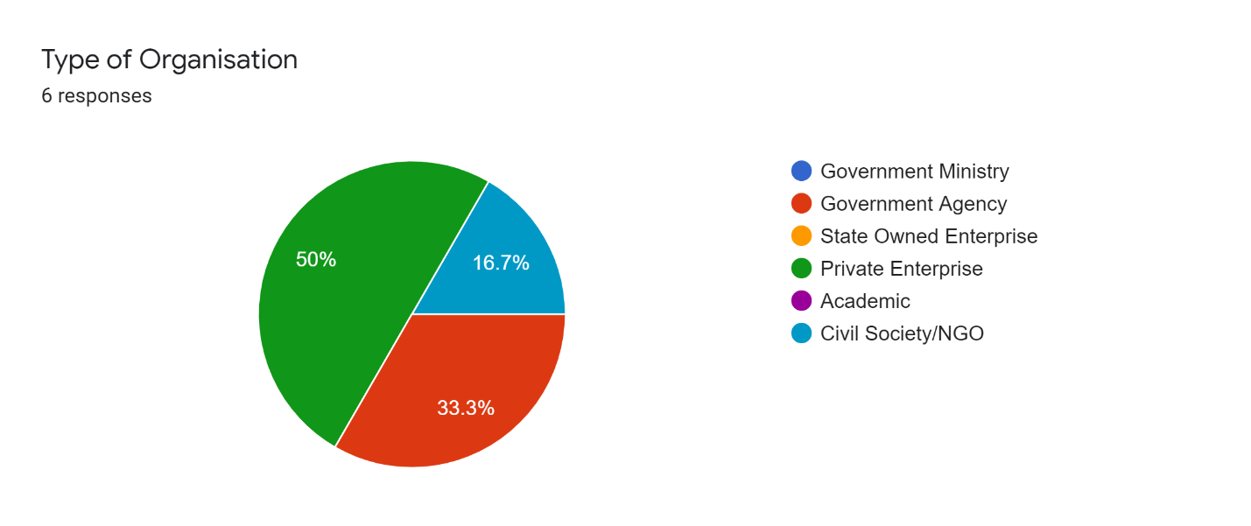
Figure 1: Types of Organizations
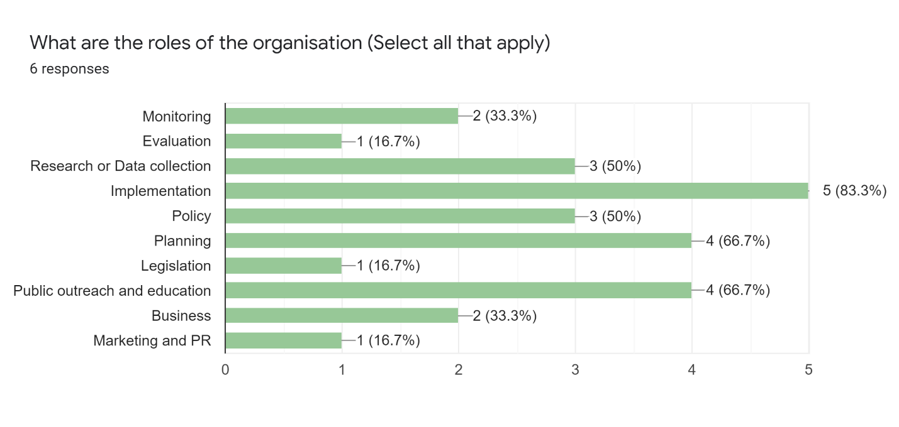
Figure 2: Responsibilities of Organizations
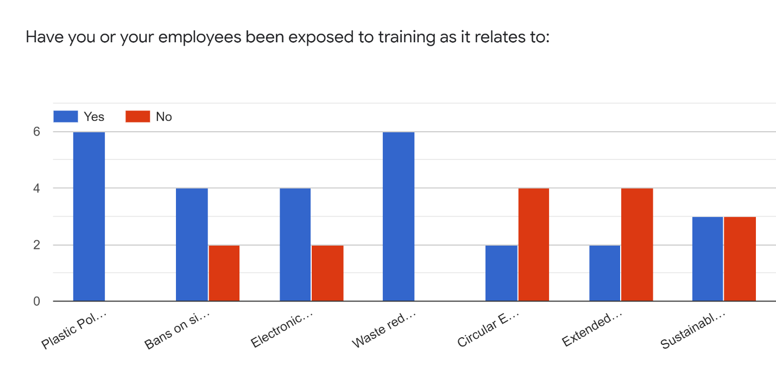
Figure 3 :Training

The results show that there has been a mix of respondents which provided some training on the issues related to plastic waste, plastic bans, etc, and respondents that did not provide such training.
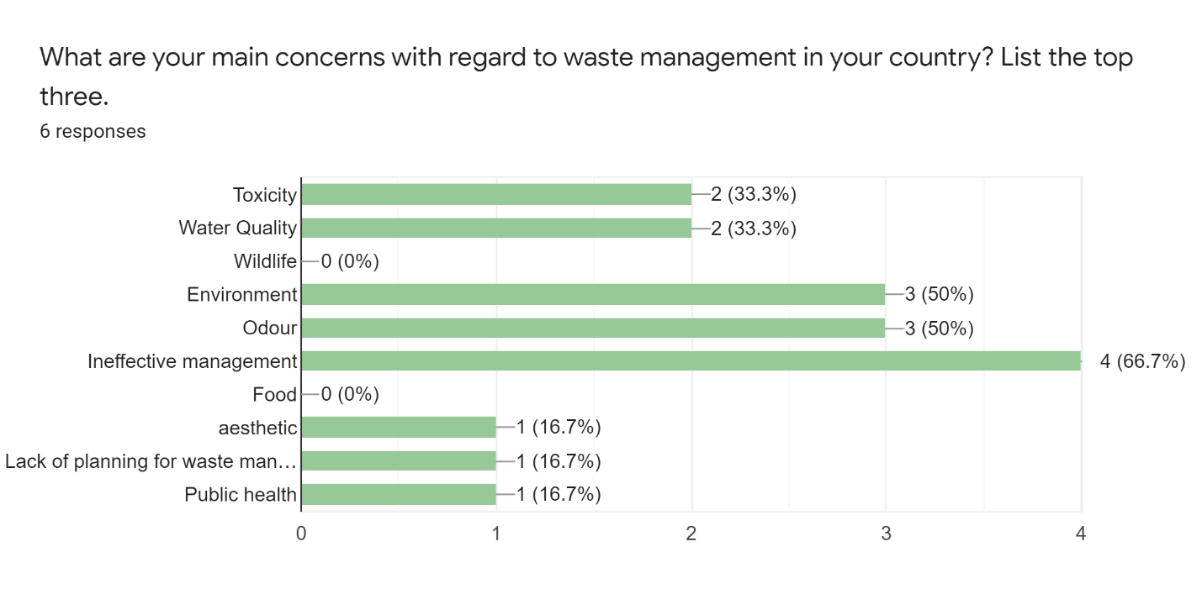
Figure 4: Main Concerns Regarding Waste Management
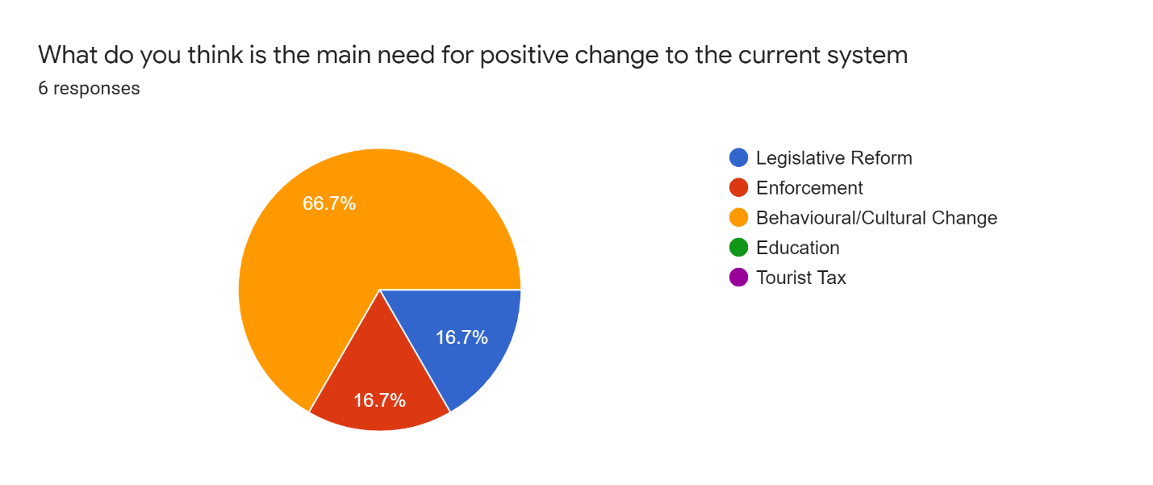
Figure 5: Need for Positive Change
The limited data set shows that the need for behavioural/cultural changes towards waste management was identified as the most important requirement for implementing positive change, followed by legislative reform and enforcement.

In terms of secondary data, stakeholder engagement will need to be established. Some of the primary data collection techniques include using local community surveys, focus group meetings, and interviews with tourism workers, interviews with tour operations, site surveys, aerial photography, water sampling and coral reef monitoring. The use of a visitor book and visitor questionnaires using open-ended questions can assess satisfaction either independently or when added to an existing survey in each territory. This is up to the tourism ministries or agencies in each territory to implement.

- Results and Assessment
Primarily, the foreign tourist generates waste at the accommodation site, e.g. hotels, hostels, B&Bs and locations where they can spend the night. The secondary point where waste is generated would be the destination’s tourism products or sites and attractions.

This generated waste can potentially reach the sea and persist as marine litter. Waste can be characterised in the following table for further study:
Key Issue | Indicator | Data
Solid Waste | No. of truckloads of waste in tourist season/No. truck loads of waste in non-tourist season | Data on trucks per month
Liquid Waste | No. of tourism properties with access to tertiary waste treatment/all properties | No. of tourism properties No. connected to tertiary plant
Coastal Water Quality | % of coastal water testing sites testing with > recommended levels of coliform bacteria | No. of testing sites No. sites failing coliform tests
Coral Reef | % of local residents who have seen decrease in reef quality over year | No. of dive operators No. noting quality decrease
Forest Trails | Number of people per day and average group size on most popular trail/capacity of trail per day | Capacity

It is necessary to implement a holistic waste management system in the destination alongside the tourism based solid waste management techniques proposed. Tourism based litter intermingles with domestic waste and it must be treated as a parallel issue. While tourism facilities and destinations require certain unique measures, such as signage in multiple languages and extra manpower for sanitation purposes, the waste that is already in the environment as litter must also be taken into consideration that may not have a source that is easily traceable.

The topic of marine litter must be further discussed at a physical level, as expressed in this adaptation of a table from Baltic Marine Environment Protection Commission (2014):

Physical Division | Methodology required | Benefits | Limitations
Coastline | Counts of the amount of litter items on known stretches of coast. In the Caribbean this data can come from the ICC | Allows for assessment of composition, amounts, and trends. Can be coupled with sorting | Very small items and microparticles in sediments are not easily counted. Not all coasts are accessible
Sea surface | Surface observation of floating litter along transects | Precise evaluation at local scale. Can be coupled with skim collection for disposal | Depending on weather. Not at large scale, small debris not considered, strong variation
Sea surface and water column | Skimming | Precise evaluation at local scale, consider smaller debris | Costs, strong temporal variation
Sea floor shallow | Visual survey with divers | All substrate types, possible to replicate | Depth and cost limitations
Sea floor, deep sea | Trawling, Submersibles and remote operated vehicles | Many forms of litter sink and many parts of the EEZ of Caribbean nations are deep sea | Depth and cost limitations
Entanglement rates of marine organisms | Entanglement rates in carcasses and live organisms found on the coastline | Can be carried out as part of existing surveys | Standard protocol would need to be developed and implemented, partnering civil society
Ingestion by marine organisms | Mass of plastic in stomachs of carcasses on shoreline | Gives a good representation on ecological impact and a base for estimation of total impact. | Methodology will need further developing to ensure it is replicable for all sites, usually requires veterinary or similar skill set
Microplastic on shorelines | Extraction of fragments from sediment samples and subsequent identification | Positive identification of specific polymers | Requires collectionand microscopy that may not be available in country
Microplastic at sea surface | Skimming sea surface | Positive identification of specific polymers, and can coincide with planktonic survey | Time-consuming analysis and is unable to detect all of the microparticles, may not be available in country
Socio-economic | Assessment of direct relationships through survey-based methods | Provides indication of economic burden on marine and coastal sectors as well as the public | Does not capture full impact of degradation of ecosystem goods and services due to marine litter and their full cost.
- Strategic Action Plan
In this proposal, measures are grouped under three categories:
- Reducing littering by influencing the behavior of selected target groups− (behavioral measures, aimed at changing the attitudes and perceptions that drive littering)
- Measures which public authorities could implement to prevent littering (preventive measures, aimed− at improving the quality of infrastructure and product and packaging design)
- Measures which aim at cleaning up litter in the environment (clean-up measures, addressing the− context that drives littering)

Aims of the action plan:
- Reduce tourism based marine litter
- Improve understanding of the regulatory framework associated with tourism based marine litter
- Enhance awareness, education and training.

Full Strategic Action Plan attached as Appendix 4.

- Regional Best Practices
The best practices currently found in the region for tourism based waste management are few but interesting and can be seen as foundation on which regional best practices can be based.

To create regional best practices, the following are proposed:
- Identification of the problem areas with a tourism lens
- Identify the controls for managing litter with a tourism lens
- Identify target groups and stakeholders in depth
- Map existing measures and analyse gaps in all sectors
- Select measures to fill these gaps specific to each territory
- Propose to the territories, possibly under a regional body
- Agree and implement the programme
- Monitor the changes over time and modify with changes

This can be done via the following methods:
- Information and guidance sharing with local authorities, civil societyand stakeholders in the private sector, especially verified data, on amounts and sources of marine litter
- Encouraging civil society and stakeholders in the private sector to launch measures relevant to their field of activity by increasing funding and facilitating bottom-up approaches to take place
- Assisting local authorities to identify target groups responsible for littering and lobby for responsible packaging
- Ensuring that neighboring authorities are aware of actions, so that they can be effectively coordinate
- Providing a communication platform for information sharing and collaboration for the region
- Providing guidance and resources to help local authorities select and implement methods to address marine litter
- Assisting local authorities as well as civil society to monitor the effectiveness of actions

Regional Toolkit and Best Practices Consolidation
- Trash Free Waters Initiative in the Caribbean
  - Website: https://www.unep.org/cep/trash-free-waters-initiative-caribbean
- Integrated Waste Management including Renewable Energy Limits and Potential for Waste Management to Energy Generation in the Caribbean
  - Website http://www.oas.org/en/sedi/dsd/energy/doc/integratedwastemanagement.pdf
- Solid Waste Management in the Caribbean
  - Website https://digitalcommons.bucknell.edu/cgi/viewcontent.cgi?article=1710&context=fac_journ
- Municipal solid waste management in the Caribbean A benefit-cost analysis
  - Website https://repositorio.cepal.org/bitstream/handle/11362/5053/S2012122_en.pdf
- SICA: Preventing plastic waste in the Central American and Caribbean Sea (CIRCULAR CARIBBEAN)
  - https://www.giz.de/en/worldwide/92233.html
- Solid Waste Management in the Caribbean – Proceedings Caribbean Solid Waste Conference
  - Website https://publications.iadb.org/publications/english/document/Solid-Waste-Management-in-the-Caribbean-Proceedings-from-the-Caribbean-Solid-Waste-Conference.pdf
- A Toolkit for Monitoring and Managing Community-Based Tourism
  - Website: http://www.bibalex.org/search4dev/files/283814/115937.pdf
Some notable case studies of best practices are summarised as follows:
Hotels:
- Casuarina Beach Club, Barbados
Yard waste is put through a Chipper Machine in order to be used in the hotel’s composting facility. Toilet tissue is a recycled product. Many drinks are on tap as opposed to individual bottles, and the use of straws is restricted. Reusable plastic glasses are also used in preference to single use. The use of plastic bags, plastic wrap and foil is minimized, and 100% biodegradable plastic bags used when necessary. Garbage bags are replaced only when soiled and reusable cloth bags are available in the MiniMart. “Ends” of soap are taken to the Salvation Army and old furniture/soft furnishings are given away to the needy.

- Punta Cana, Dominican Republic
The Grupo Puntacana Foundation (FGPC) confronts diverse environmental challenges by developing innovative solutions implementing them in experimental projects. The foundation has worked with solid waste, coral reefs, endangered species, private ecological reserves and many other areas, providing innovative solutions including golf courses with high salinity tolerance to reduce water consumption and zero waste initiatives as well as extensive composting and waste reduction strategies.
- True Blue Bay Boutique Resort, Grenada
At True Blue Bay Boutique Resort, all the food waste goes either to the onsite composting system or supplied to local pig farmers. Garden waste is also composted and the compost is used to nourish the plants on the hotel grounds, contributing to a circular economy. Staff now use reusable locally made masks, as well as reusable aprons that are washed and disinfected. Staff are trained to wash hands constantly, so that they do not have to use disposable gloves.
- Castara Retreats, Tobago
Castara Retreats employed local people to build and create the facility. Whilst the style of the accommodations is unique, they ensured the construction process derived from local labour, materials and practice. Some 40 people from the village helped build Castara Retreats, and take pride in what they have helped achieve. They have undertaken extensive tree and shrub planting to maximise soil retention and avoid the risk of soil erosion and landslides. Paths with drainage systems have been constructed to ensure the safe run off of water from the land to the highway below. They have also created composting areas used by both our guests and our restaurant for disposing of vegetable and plant waste. The compost is then used for feeding our garden plants and trees, nurturing their growth and development.

Cruise:
- Disney Cruise Lines
The DCL company aims to minimize the environmental impact of its cruise ships by focusing on new technologies, increasing energy efficiency, reducing the amount of generated waste, educating its employees and customers, while also promoting environmental conservation around the world. Complex and robust waste streaming and in depth analysis into the different types and treatment of wastes generated are implemented. There are also activities that are restricted in each port of call, including discharge of bilge and ballast water and incineration.
- Carnival Cruise Lines
Carnival Corp. is still on probation following several violations for which it was fined tens of millions of dollars, the environmental advancements Carnival Cruise Line has made on its newest ship, Mardi Gras, are notable. Innovations in fuel, reduction and in some cases elimination in single use packaging and overall management of food waste have not only reduced the overall waste footprint onboard, the costs associated with managing and disposing of the waste are now minimal.

Indigenous communities:
- Kalinago Community, St Lucia
The first inhabitants of St Lucia were the indigenous Kalinago (Caribs) who had originally settled on the islands across the Caribbean and were noted for the fierce resistance they mounted for more than a century against attempts at European colonization. The remaining community maintains traditions of solid waste management.

Legislation:
- Beach Control Act 2005, Jamaica
The legislation notes that “such activities as may be specified in the order to be prohibited activities in the area defined in the order, being any or all of the following activities-... the disposal of rubbish or any other waste matter.”

Education:
- Grenada Solid Waste Management Authority, Grenada
The Environmentally Friendly School Initiative (EFSI) is a programme targeting pre-primary, primary and secondary schools where, for nine months each year, participants undertake projects that focus on different aspects of solid waste management. Projects can cover public education, litter management, waste minimisation, and the nexus between waste management and tourism.
Overall findings can be narrowed to the following:
- Legislation
- Education
- Supply of goods and services that result in waste and waste refusal
- Waste generation
- Waste reuse
- Waste re purpose
- Waste recycling
- Waste disposal
- Pollution management and control
- Data collection, monitoring, reporting and verification (MRV)

- Regional Stakeholders
The cross section of stakeholders required to implement change in each state must be representative. This means it must include members of the following:
- Government Ministries
- Government Agencies
- Political interests
- Media
- Private Sector
- Education System
- Community, Civil Society
- NGOs, CBOs, Not for profit organisations

See Appendix 2 for the regional stakeholders identified.

- SWOT Analysis and Gap Analysis
A SWOT Analysis is presented in the diagram below:

A gap analysis is presented in the table below:
Focus Area | Current State | Desired State | Gap | Recommendations
Solid Waste Management System | Aged infrastructure and poor management | Efficient and effective waste management | Management systems and actors | Increase maintenance programmes, strengthen capacities and enforce positive change.
Solid Waste Rate of Production/Quantity | Single use items being produced and used without thought | Reduction in production and refusal of use of wastes that can not be broken down naturally | Alternatives to single use items that are cost effective or socially acceptable | Stop import and production of unsustainable single use items. Reintroduce the concept of waste reduction and 5 Rs
Solid Waste Legislation | Aged and not adequately enforced | Updated and robust | Does not specifically cover tourism based wastes | Update aged legislation and propose new legislation where needed
Solid Waste Monitoring | Inconsistent information | Representative data set that can inform policy | Consistent data collection | Implement a policy for data collection with regard to wastes and ensure it is representative
Tourism Based Solid Waste Monitoring | Inconsistent information | Representative data set that can inform decision makers | Consistent and detailed data collection | Implement a policy for data collection with regard to wastes and ensure it is representative
Tourism Based Solid Waste | Single use items being used | Reduction in production and refusal of use of wastes that can not be broken down naturally | Alternatives to single use items that are cost effective or socially acceptable | Ensure tourists do not import unsustainable single use items. Enforce the concept of waste reduction and 5 Rs
Tourism based solid Waste Awareness | Not much understanding on the impacts | More education and awareness on the issues so the effects can be managed | Lack of awareness and understanding | Community and tourism operator awareness and management of tourism generated waste

- Proposed Activities
Online Training
There is need for more education and knowledge sharing as it relates to addressing the problems of marine litter. Such training can be applicable to many of the stakeholders identified in section 6.0 of this document.

Educational and awareness campaigns need to be developed and implemented as a way to encourage increased involvement of NGOs and the private sector in the development and programming stages. The use of radio and television advertisements, printed educational materials (brochures, posters) need to be used more effectively to reach government agencies, NGOs, CBOs, business and industry groups. Educational components (curriculum aids/activity sheets) need to be more accessible to educators in the integration of the solid waste management issue into the school curriculum. There is a lack in the use of social media to aid in delivering the message to the younger audience and other groups so this is an area for further exploration.

Education has not been directed to specific user-groups (i.e., fishermen, yachtsmen) who are needed to help address marine litter issues. Education and awareness campaigns should target schools and communities to get into waste minimisation practices such as composting, recycling etc. Some programmes have started in schools in some countries but more can be done. Additionally, the entertainment industry has been growing and most events tend to be held on the or near to the beach area, producing a lot of waste there. Therefore, education should target events managers and organisers to manage waste at the event properly. They could also notify or hire the local solid waste management agencies to clean after the events (UNEP, 2014).

Feedback from stakeholders suggest that there is keen interest in reducing their environmental footprints, reducing their waste generation, exploring opportunities for recycling and reuse as well as resource conservation, but there is generally a lack of knowledge on how to implement such processes.
Online training can be structured in several different ways to meet the needs of various stakeholders involved. There can be a tiered level training for beginners, intermediates, and experts. Alternatively, there can be modules on various segments of marine litter management.

Suggested modules are as follows:
- Marine Litter and its Impacts
- Marine Litter Governance
- Technical Solutions: Alternative Products to Reduce Marine Litter
- Technical Solutions: Recycling Processes for waste diversion
- Technical Solutions: Clean-up of Marine Litter
- Marine Litter Measurements
- Effective Strategies for Marine Litter Reduction
- Application of Toolkits in Marine Litter Prevention

The following activities are proposed for the development of the online training program:
- Develop Needs Assessment
- Develop Learning Objectives and Factors of Success
- Design Training Modules
- Pilot Test Training Program
- Finalize Training Program
- Advertise and Launch Training Program

Application of Waste Management Toolkit

A toolkit is required to assist decision makers and agencies in managing parallel culture change and waste management. A draft toolkit has been prepared and included in appendix 3. For the purpose of tourism based solid waste management to combat marine litter, the proposed toolkit includes:
- Legislation
- Education
- Supply of goods and services that result in waste and waste refusal
- Waste generation
- Waste reuse
- Waste re purpose
- Waste recycling
- Waste disposal
- Pollution management and control
- Data collection, monitoring, reporting and verification (MRV)

In order to effectively utilize the toolkit the following activities are proposed:
- Identification of a few stakeholders within the target countries to pilot test the toolkit.
- Identify limitations/constraints with the application of the toolkit.
- Revision of the toolkit based on the pilot testing phase.
- Issuance of the toolkit to all relevant stakeholders for their implementation.
- Provision of technical support to address queries/challenges during the implementation phase

Capacity Development for Micro, Small and Medium Sized Enterprises

Micro, Small and Medium Enterprises (MSMEs)within the tourism sector can be targeted for capacity development as it relates to marine litter interventions through the application of best practice approaches to waste management. The capacity development would comprise the following activities:
- Identification of a number of key MSMEs within the target countries to participate in pilot study
- Conduct pilot study within MSMEs to determine the amount and types of waste generated, along with options for waste reduction, reuse and recycling.
- Develop pilot activities for implementation of 3R’s approach to waste management in the MSMEs
- Develop Manual for Capacity Building for MSMEs within the Tourism Sector
- Disseminate manual within Caribbean territories for implementation

Updating of Existing Toolkits

Section provides information on some of the existing toolkits that have been developed. There is a need to update these toolkits to ensure continued relevance and to address constraints that may prevent them from being utilized for full benefit. The approach to updating these toolkits are as follows:
- Develop full inventory of toolkits that have been developed relevant to waste management, and marine litter in the Caribbean.
- Review cases where the toolkits have been utilized and assess the results obtained.
- Review toolkits for relevance, practicability, and ease of implementation.
- Revise/Update toolkits based on ii and iii. above.

- Budget
The proposed budget is as follows (Prices are expressed in United States Dollars). These budget prices are for consulting fees only and do not include overheads, project management fees or reimburseables.
Activity | Budget | Timeline
Online Training | $28,750 | 6 months
- Develop Needs Assessment | $5,000 | 1 month
- Develop Learning Objectives &Factors of Success | $2,500 | 2 weeks
- Design Training Modules | $10,000 | 2 months
- Pilot Test Training Program | $5,000 | 1 month
- Finalize Training Program | $1,250 | 1 week
- Advertise and Launch Training Program | $5,000 | 1 month
Waste Management Toolkit | $21,250 | 6 months
- Identification of a few stakeholders to pilot test the toolkit. | $1,250 | 1 week
- Identify limitations/constraints with the toolkit. | $5,000 | 1 month
- Revision of the toolkit based on the pilot testing phase. | $2,500 | 2 weeks
- Issuance of the toolkit to stakeholders for implementation. | $2,500 | 2 weeks
- Provision of technical support to address queries/challenges | $10,000 | 1 month
Capacity Development for MSMEs | $38,750 | 8 months
- Identification of a number of key MSMEs | $1,250 | 1 week
- Conduct pilot study within MSMEs | $10,000 | 2month
- Develop pilot activities | $20,000 | 4 months
- Develop Manual for Capacity Building for MSMEs | $5,000 | 1 month
- Disseminate manual for implementation | $2,500 | 2 weeks
Updating Existing Toolkits | $15,000 | 3 months
- Develop full inventory of toolkits | $1,250 | 2 weeks
- Review toolkit utilization and assess the results obtained. | $5,000 | 1 month
- Review toolkits for relevance, etc | $2,500 | 2 weeks
- Revise/Update toolkits based on ii and iii. above. | $5,000 | 1 month

- References
IISD. 2021. “IMO Adopts Action Plan on Marine Litter.”
https://sdg.iisd.org/news/imo-adopts-action-plan-on-marine-litter/

Attzs, Marlene. 2014. “Survey and assessment of environmental taxes in the Caribbean”
https://publications.iadb.org/publications/english/document/Survey-and-Assessment-of-environmental-Taxes-in-the-Caribbean.pdf

CDB. 2019. “Measuring Vulnerability-A Multidimensional Vulnerability Index for the Caribbean.”
https://www.caribank.org/sites/default/files/publication-resources/Measuring%20Vulnerability-A%20Multidimensional%20Vulnerability%20Index%20for%20the%20Caribbean.pdf

Riquelme, Rodrigo. 2016. “Solid waste management in the Caribbean: proceedings from the Caribbean Solid Waste Conference.”
https://publications.iadb.org/publications/english/document/Solid-Waste-Management-in-the-Caribbean-Proceedings-from-the-Caribbean-Solid-Waste-Conference.pdf

Baltic Marine Environment Protection Commission. 2014. “A proposal for marine litter work in HELCOM.”
https://portal.helcom.fi/meetings/LAND%2019-2014-111/MeetingDocuments/5-2%20Proposal%20for%20marine%20litter%20work.pdf

UNEP. 2014 “Regional Action Plan on Marine Litter Management (RAPMaLi) for the Wider Caribbean Region”
https://www.cbd.int/doc/meetings/mar/mcbem-2014-03/other/mcbem-2014-03-115-en.pdf

Appendix 1–SurveyTool
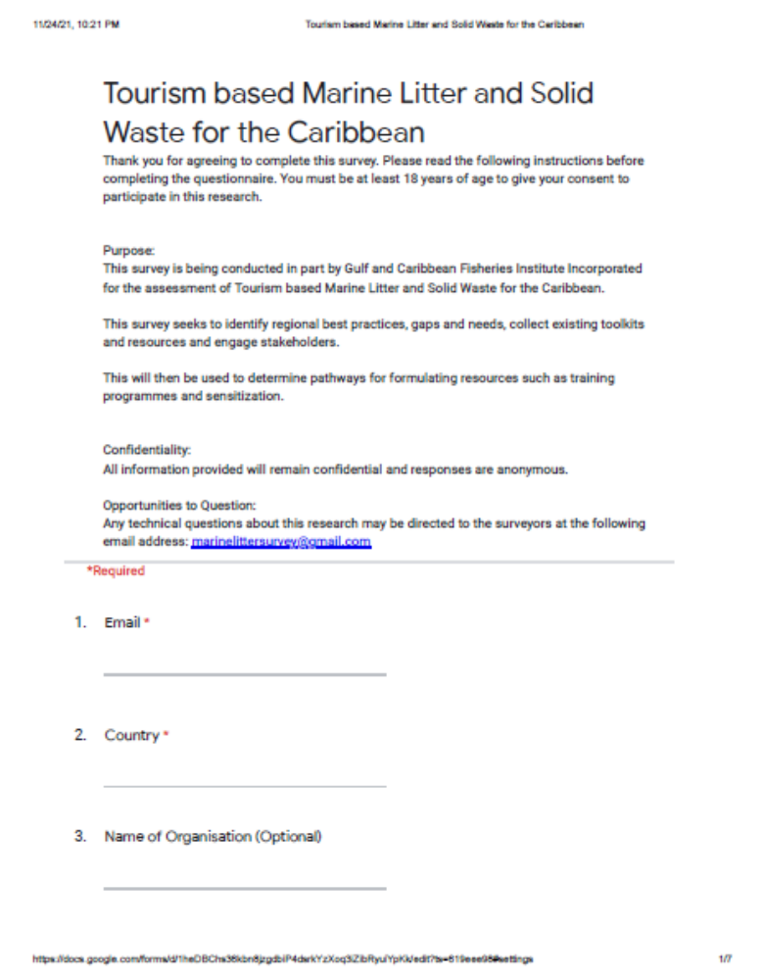

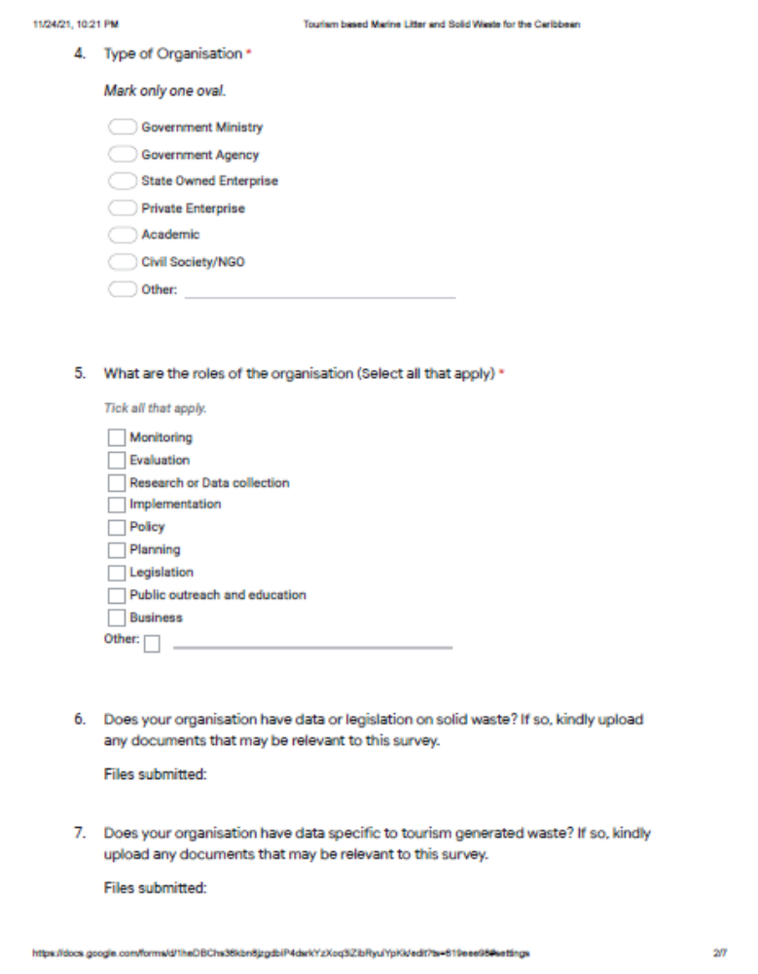

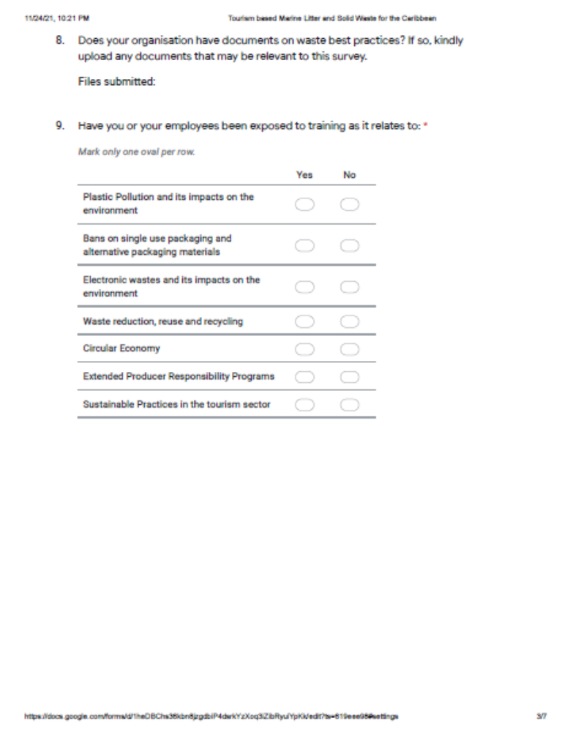

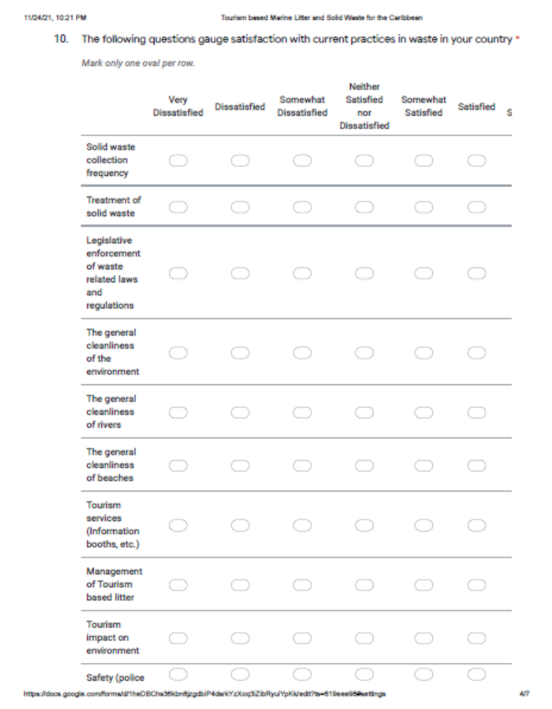

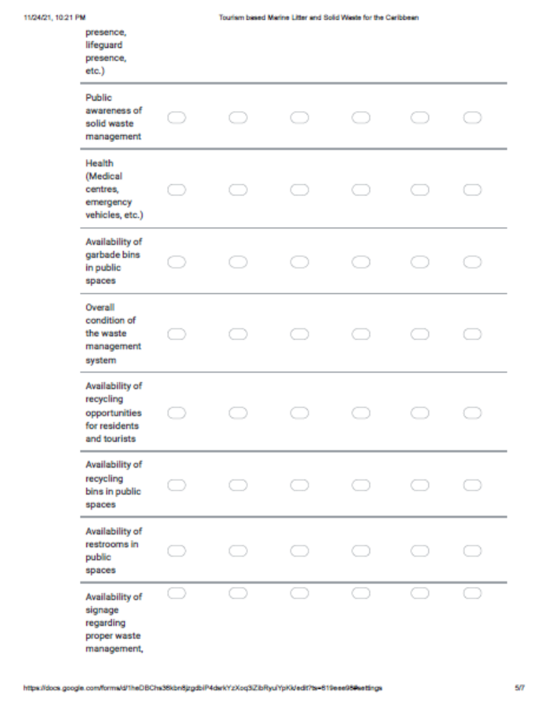

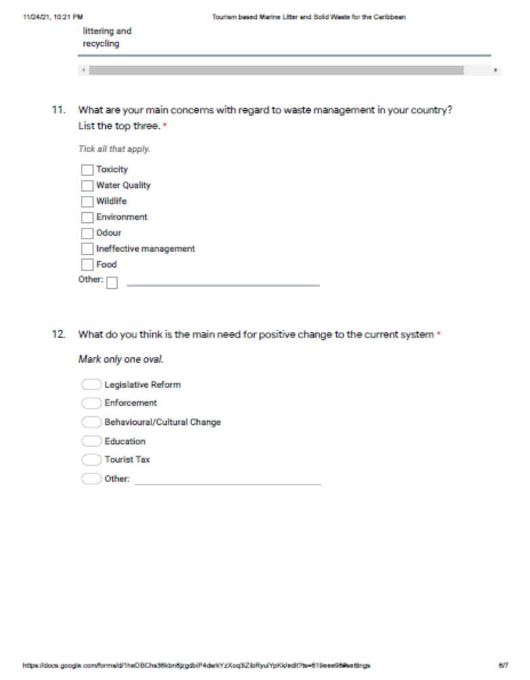

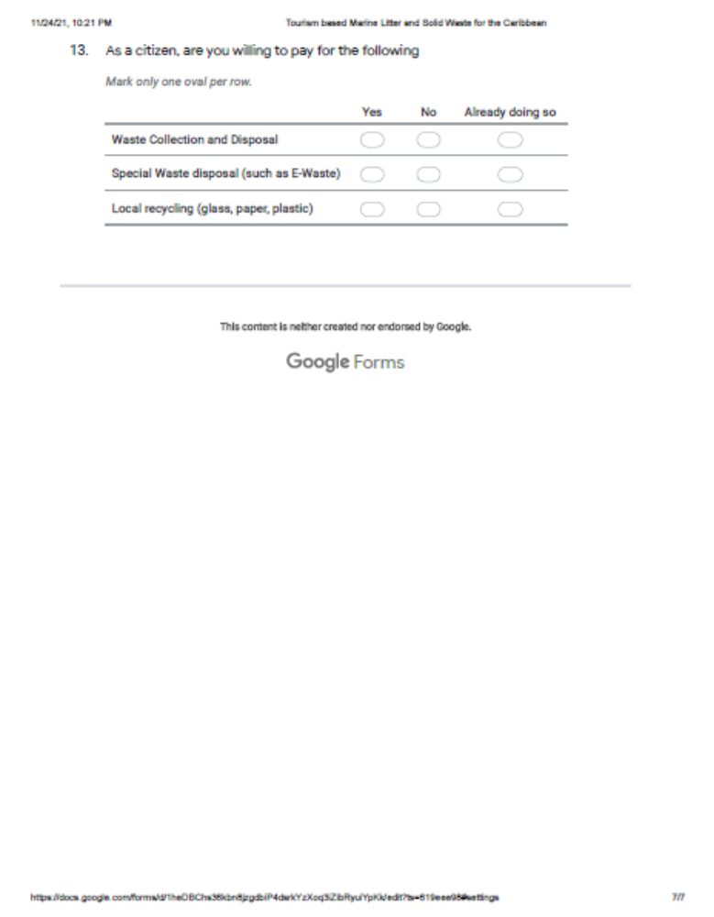

Appendix 2 – Stakeholder Listing

Jurisdiction | Organization | Email | Website | Address | Tel No/s | Type of Stakeholder
Caribbean | Caribbean Tourism Organisation | Ssmith@caribtourism.com | Https://www.onecaribbean.org/ | 7th Floor Baobab Tower, Warrens  St Michael, BB 22026, Barbados | 1 246 427 5242 | International Inter-governmental Organisation
Caribbean | Sustainable Destinations Alliance for the Americas |  | Https://sustainabletravel.org/project/sustainable-destinations-alliance-for-the-americas/
Caribbean | CANARI | Communications@canari.org | Https://canari.org/ | #105 Twelfth Street, Barataria, Trinidad | 1-868-638-6062 | NGO
Eastern Caribbean | Environmental Protection in the Caribbean (EPIC) |  | Http://epicislands.org/index.html | 2 Nile Drive  Maho, Sint Maarten  Dutch West Indies | 1 (721) 545-3009 | NGO
Eastern Caribbean | OECS | Oecs@oecs.int | Https://www.oecs.org/en/marine-pollution-eastern-caribbean | Morne Fortune, P.O. Box 179  Castries Saint Lucia | 1 758-455-6327 | International Inter-governmental Organisation
Grenanda | NEWLO | Info@newlo.org | Https://newlo.org | Palmiste, Saint John, Grenada, West Indies | 1 (473) 444-8532 | NGO/Training
Grenanda | GRENCODA | Grenco@spiceisle.com | Http://grencoda.org/ |  | 1 473-444-8430 | NGO/Training
Grenanda | Grenada Fund for Conservation Inc | Gfcinc1@gmail.com | Https://www.grenadafundforconservation.org/ | St. John's Street Unit 4, GRENCODA Resource Complex, Saint Georges | 1 (473) 404-5814 | NGO
Grenanda | Grenada Solid Waste Management Authority | Gndgswma@gswma.com | Http://www.gswma.com/general.htm | PO Box 1194, Grand Anse,  St.George’s Grenada,  West Indies. | (473) 444-2019 or (473) 444-3009 | Government
Grenanda | Ministry of Agriculture, Lands, Forestry, Fisheries and the Environment | Agriculturegrenada@gmail.com | Https://gov.gd/mocr/ | Ministerial Complex  Sir Eric Matthew Gairy Botanical Gardens  Tanteen  St. George’s, Grenada, W.I. | 1 (473) 440-3386 | Government
Grenanda | Ministry of Tourism, & Civil Aviation | Tourism@gov.gd | Https://gov.gd/motc/ | Ministerial Complex  Sir Eric Matthew Gairy Botanical Gardens  Tanteen  St. George’s, Grenada, W.I. | 1 (473) 440-0366 | Government
Jurisdiction | Organization | Email | Website | Address | Tel No/s | Type of Stakeholder
Grenanda | Grenada Hotel & Tourism Association |  | Https://ghta.org/ | Grenada Hotel & Tourism Association  Ocean House Building,  Morne Rouge RD  St. George, Grenada | 1(473) 444-1353 | NGO
Grenanda | Grenada Tourism Authority | Info@puregrenada.com | Https://www.puregrenada.com/ | Burns Point, St. George's  Grenada W.I | (473) 440-2001 | Government
Antigua & Barbuda | National Solid Waste Management Authority | Nsmwa@solidwaste.gov.ag | Https://health.gov.ag/departments/national-solid-waste-management-authority/ | Sir George Walter, Highway, Piggotts, Antigua & Barbuda | 1 268-562-1348 | Government
Antigua & Barbuda | Ministry of Health, Environmental Division | Antiguaenvironmentdivision@gmail.com | Https://www.environment.gov.ag/en/ | Department of Environment  #1 Victoria Park Botanical Gardens  Factory Road  St. John’s, Antigua, W.I. | 1(268) 462 4625 | Government
Antigua & Barbuda | Antigua and Barbuda Tourism Authority | Info@visitaandb.com | Https://visitantiguabarbuda.com/ | Antigua and Barbuda Tourism Authority  Third Floor, ACB Financial Centre  High St  St John’s, Antigua | 1-268-562-7600 | Government
Antigua & Barbuda | Wallings Nature Reserve | Info@wallingsnaturereserve.org | Https://www.wallingsnaturereserve.org/ | John Hughes, Antigua & Barbuda | 1 268-727-0218 | NGO
Antigua & Barbuda | The Environmental Awareness Group of Antigua & Barbuda | Eagantigua@gmail.com | Https://www.eagantigua.org/ | P.O. Box 2103  St. John’s, Antigua | 1 (268) 462-6236 | NGO
Dominica | Dominica Solid Waste Management Corporation | Dswmc@cwdom.dm | Http://www.dswmc.dm/ | Great Marlborough Street, Roseau | (767) 449 8168 | Government
Dominica | Ministry of Tourism, International Transport and Maritime Initiatives | Tourism@dominica.gov.dm | Https://tourism.gov.dm/ | Ministry of Tourism, International Transport and Maritime Initiatives  3rd Floor, Government Headquarters  Kennedy Avenue, Roseau  Dominica | 1 (767) 266 3497 | Government
Dominica | Discover Dominica Authority | Tourism@dominica.dm | Https://discoverdominica.com/en/home | 5 - 7 Great Marlborough Street  P.O. Box 293, Roseau, Commonwealth of Dominica | 1 (767) 448-2045 | Government
Jurisdiction | Organization | Email | Website | Address | Tel No/s | Type of Stakeholder
Dominica | Dominica's Sea Turtle Conservation Organization Inc. | Info@domsetco.org | Https://dominicaturtles.org/ |  | 1 (767) 265-0908 | NGO
Montserrat | Environmental Health Department | Environmentalhealth@gov.ms | Https://www.gov.ms/government/ministries/ministry-of-health-and-social-services/environmental-health-department/ | Environmental Health St Johns’ Clinic St Johns | 1 664-491-6057 | Government
Montserrat | Montserrat Tourism Division | Info@visitmontserrat.com  info@montserrattourism.ms | Https://www.visitmontserrat.com/ | Hubert Buffonge Building Brades, Montserrat | 1 664 491 4703 | Government
St. Kitts & Nevis | St. Kitts Tourism Authority |  | Https://www.stkittstourism.kn/ | P.O. Box 132 • Pelican Mall  Basseterre, St. Kitts | 1 869-465-4040 | Government
St. Kitts & Nevis | St. Kitts Solid Waste Management Corporation | Info@stkittsswmc.com | Https://www.stkittsswmc.com/ | Address: P.O. Box 1280, Taylors Range, Basseterre | 1 (869) 465-9507 | Government
St. Kitts & Nevis | Ministry of Sustainable Development | Planningstk@sisterisles.kn | Https://www.gov.kn/ | Government Headquarters  Church St, Basseterre, St. Kitts & Nevis | 1 (869) 467-1256 | Government
Saint Lucia | Saint Lucia Solid Waste Management Authority | Admin@sluswma.org | Https://www.sluswma.org/ | Sans Souci, Castries | 1-758-453-2208 | Government
Saint Lucia | Ministry of Tourism, Investment, Creative Industries, Culture and Information | Psmot@gosl.gov.lc | Http://www.govt.lc/ministries/tourism-heritage-and-creative-industries | 3rd Floor Sir Stanislaus James Building  Waterfront Castries Saint Lucia | 1 (758) 468-4629 | Government
Saint Lucia | Coalition of Civil Society Organisations | Saintluciacsocoalition@gmail.com | Https://www.facebook.com/slucsocoalition/ | C/o Saint Lucia National Trust, Hon. Moses Matalon Causeway Gros Ilet, St. Lucia | 1 758 452-5005 | NGO
St. Vincent & the Grenadines | Solid Waste Management Unit | Cwsa@vincysurf.com | Http://www.cwsasvg.com/swmu.html | Central Water & Sewerage Authority  P.O Box 363  New Montrose  Kingstown,  St. Vincent & The Grenadines |  | Government
St. Vincent & the Grenadines | Ministry of Tourism | Tourism@gov.vc | Http://www.tourism.gov.vc/tourism/ | 2nd Floor NIS Building Upper Bay Street, Kingstown, | 1 (784) 457-1502 | Government
Jurisdiction | Organization | Email | Website | Address | Tel No/s | Type of Stakeholder
St. Vincent & the Grenadines | SVG Tourism Authority | Svgta@discoversvg.com | Http://tourism.gov.vc/tourism/index.php?Option=com_content&view=article&id=98&Itemid=103 | 2nd Floor NIS Building Upper Bay Street, Kingstown, | 1 (784) 457-1502 | Government
St. Vincent & the Grenadines | Sustainable Grenadines Inc. (Sus Gren) | Susgreninc@gmail.com | Https://susgren.org/ | Sustainable Grenadines Inc. Jerome Village, Ashton, Union Island. VC0470 – Saint Vincent and the Grenadines | 1 (784) 485-8779 | NGO
British Virgin Islands | Ministry of Health & Social Development The Department of Waste Management | Dwm@gov.vg | Http://www.bvi.gov.vg/departments/department-waste-management-0 | P.O. Box 3477  Road Town, Tortola  Virgin Islands (British) VG1110 | 1(284) 468-4934 | Government
British Virgin Islands | British Virgin Islands Tourism | info@bvitourism.com | Https://www.bvitourism.com/ | 3rd Floor, Eureka Geneva Building  Road Town, Tortola  Geneva Building  Road Town, Tortola  British Virgin Islands | 1 284-852-6020 | Government
British Virgin Islands | BVI Tourist Board | Kdawson@bvitourism.com | Https://bvi.gov.vg/tags/tourism | 33 Admin Drive, Wickhams Cay 1, Road Town, Tortola, Virgin Islands | 1 284 440-8281 | Government
British Virgin Islands | Unite BVI |  | Https://www.unitebvi.com/ |  |  | NGO
Anguilla | Waste Management |  | Http://www.gov.ai/waste_management.php |  | 1 (264) 497 2631 | Government
Anguilla | Anguilla Tourism | Info@ivisitanguilla.com | Https://ivisitanguilla.com/ | P.O. Box 1388 Coronation Avenue The Valley, Anguilla, AI-2640 | 1(264) 497-2759 | Government
Anguilla | Anguilla Tourist Board | Atbtour@anguillanet.com | Http://www.gov.ai/tourism.php | Coronation Avenue The Valley Anguilla, WI | 1 (264) 497 2759 | Government
Anguilla | Anguilla National Trust | Fm.axatrust@gmail.com | Https://axanationaltrust.com/ | Anguilla National Trust, Museum Building, Albert Lake Dr., P.O. Box 1234, The Valley, AI-2640 Anguilla | 1 (264) 497-5297 | NGO
Martinique (France) | AGEFMA (Environmental Management) | Agefmacarif@agefma.fr | Https://www.agefma.mq/index.php?Page=accueil | Foyal 2000 building, Governor Street Ponton, 97200 - FORT DE FRANCE | 0596 71 11 02 | Government
Jurisdiction | Organization | Email | Website | Address | Tel No/s | Type of Stakeholder
The Bahamas | Bahamas Waste Limited |  | Https://www.bahamaswaste.com/ | Bahamas Waste, Gladstone Road, P.O. Box N-4827, Nassau, | (242) 361-6841 | Government
The Bahamas | The Bahamas Ministry Of Tourism And Aviation | Tourism@bahamas.com | Https://www.bahamas.com/ | P.O. Box N-3701 Nassau, Bahamas | 1 (242) 302-2000 | Government
Barbados | Barbados Solid Waste Management Programme | Pmcu.swmp@barbados.gov.bb | Http://solid.gov.bb/ | Project Management Coordination Unit, Warrens Tower II, Warrens, St. Michael Barbados | 1 246 535-4880 | Government
Barbados | Barbados Tourism Marketing Inc. | Btmiinfo@visitbarbados.org | Https://www.visitbarbados.org/ | One Barbados Place, Warrens, St. Michael, Barbados. W.I. BB12001 | 246-535-3700 | Government
Barbados | Barbados Environmental Conservation Trust | Info@barbadosenvironment.org | Https://barbadosenvironment.org/ |  |  | NGO
Haiti | Visit Haiti | Info@visithaiti.com | Https://visithaiti.com/ |  | (+509) 3768-3534 | Government
Jamaica | National Solid Waste Management Authority | Nswma@nswma.gov.jm | Http://www.nswma.gov.jm/ | 61 Half Way Tree Road, Kingston 10 | 876-960-4511 | Government
Jamaica | Jamaica Environment Trust | Jamaicaenvironmenttrust@gmail.com | Https://www.jamentrust.org/ | Earth Cottage, 123 Constant Spring Road, Unit 5, Kingston 8, Jamaica W.I. | (876) 960-3693 | NGO
Sint Maarten | The Ministry of Public Housing, Spatial Planning, Environment and Infrastructure | Dcomm@sintmaartengov.org | Http://www.sintmaartengov.org/government/VROMI/Pages/default.aspx | Soualuiga Road #1, Pond Island, Great Bay, St. Maarten | (721)-542-0349 | Government
Trinidad and Tobago | SWMCOL | Info@swmcol.co.tt | Https://www.swmcol.co.tt/ | #34 Independence Square North, Port of Spain, 100208 | 1868-612-7962 | Government
Trinidad and Tobago | Siel Environmental Services Limited | Sian.young@sielenvironmental.com | Https://linktr.ee/sieltt?Fbclid=iwar0b935zlzwb06utmlc3dxlzqrdxicrrhkpurj_aqlxqbqqarjgncqwqfws | LP 55 Amethyst Drive 00000 El Dorado, Trinidad and Tobago | (868) 381-9937 | Training
Trinidad and Tobago | Visit Trinidad |  | Https://visittrinidad.tt/ | 1A Wrightson Rd, International Waterfront Tower D, Level 18 Port of Spain | 1 868 612 7412 | Government
Trinidad and Tobago | Visit Tobago | Info@tobagotourism.org | Https://www.visittobago.gov.tt/ | Tobago Tourism Agency, Pleasant House, Corner of Bacolet Ext. Road and Hamilton Street, Scarborough | 1 868 612 8825 ext 2001 | Government
Jurisdiction | Organization | Email | Website | Address | Tel No/s | Type of Stakeholder
Trinidad and Tobago | THA Tourism, Culture and Transportation | Information@tha.gov.tt | Https://www.tha.gov.tt/divisions/dotct/ | #12 Sankar Building, Sangster’s Hill, Scarborough | (868) 639-2125 | Government
Trinidad and Tobago | Ministry of Tourism, Culture and the Arts | Media@tourism.gov.tt
Cuba | Municipal Communal Services Administration |  | Https://www.redisla.gob.cu/en/procedures-and-services/services/comunales/682-brashes-and-drains/7290-rubble-and-landfill-services |  |  | Government
Cuba | The Nature Conservancy | Fnunez@tnc.org, caribbean@tnc.org | Https://www.nature.org/en-us/about-us/where-we-work/caribbean/cuba/ |  | 809-697-9110 | NGO
Cuba | Cuba Travel | Cubatravel@centra.cbt.tur.cu | Https://www.cubatravel.cu/en | 3ra y 28, Playa Havana, Cuba 10500 | 53 7 2044016 | Government
The Dominican Republic | Ministry of Tourism | Info@mitur.gob.do | Https://www.mitur.gob.do/ | Avenida Luperón, esquina Cayetano Germosén Santo Domingo, República Dominicana | 809-221-4660 | Government
The Dominican Republic | MINISTRY OF THE ENVIRONMENT AND NATURAL RESOURCES | Info@ambiente.gob.do | Https://ambiente.gob.do/ | Avenida Cayetano Germosén esq. Gregorio Luperón Avenue, Ensanche El Pedregal, Santo Domingo | 809.567.4300 | Government
The Dominican Republic | Grupo Puntacana Foundation | Fgpc@puntacana.com | Https://www.puntacana.org/en/ | Grupo Puntacana Foundation | (809) 959-9221 | NGO
The Dominican Republic | Ecoservices | Info@ecoservices.com.do | Http://www.ecoservices.com.do/ | Av. Barceló, Carr. Veron-Bávaro km 4.5 detrás Agua Alaska 23000 Bávaro, Dominican Republic | 1 809-455-7111 | NGO

Appendix 3 – Waste Toolkit

Caribbean Waste Toolkit

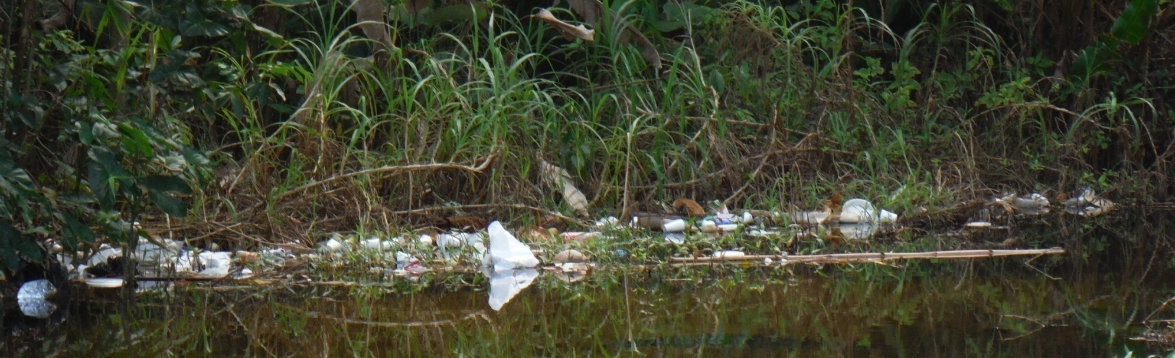

Modern life has brought with it a need for convenience, which has in turn caused production of more waste. With plastic packaging and non-linear products that are not biodegradable, waste has become less sanitary and requires diverse treatment and disposal methods. SIDS
Waste currently resides in the following main places:
- Landfills
- Incineration
- Recycling
- Export
- Dumping
- Litter
Waste is not an attractive topic, however if governments and society do not rectify the current problem, the compounded issues will be inherited by future generations. The solutions stem from the following major components:
- Legislation
- Education
- Supply of goods and services that result in waste and waste refusal
- Waste generation
- Waste reuse
- Waste re purpose
- Waste recycling
- Waste disposal
- Pollution management and control
- Data collection, monitoring, reporting and verification (MRV)
Through cooperative action, states can:
- Reduce costs
- Create local jobs
- Minimise the impact on the environment
- Harmonise land use plans
- Invest in advanced technology they could not afford independently
- Build greater respect and understanding for each other’s unique cultures, ways of life and governance structures.

This Caribbean Solid Waste Toolkit is intended to assist decision makers and agencies in managing parallel culture change and waste management.

Legislation
Solid waste is any discarded material, and can include almost anything. It can be solid, semi-solid, liquid or gas and can be organic or inorganic. Solid waste management has been defined as the systematic control of generation, collection, storage, transport, source separation, processing, treatment, recovery, and disposal of solid waste. Solid waste management is a basic need of communities. Just like access to clean drinking water, shelter, food, energy, transport and communications are essential to society, managing solid waste in a sustainable manner is essential to human and environmental health. However, the public and political profile of waste management is often lower than other services. Garbage is not attractive and therefore the issue tends to be overlooked while the problem grows. Unfortunately, the consequences of doing little or nothing to address waste management can be very costly to society and to the overall economy. Addressing solid waste management allows a community:
- To protect the public and the environment (air, water, land) from the potentially harmful health effects of waste
- To minimize waste and compost, recycle, re-use, re-sell as much as possible to use scarce resources wisely
- To maximize the economic development aspects of solid waste management, including increasing jobs, producing renewable energy, returning valuable goods to the economy
- To educate and raise awareness about efficiency in solid waste management
- To reduce the generation of waste as much as possible thereby reducing solid waste management costs and reducing the burden on the environment.
Legislation forms the basis of society, it is the rule of law of the state and must be enforced to ensure that society is sustainably managed and all rights are upheld. By forming and implementing legislation that governs all aspects of waste, the first step towards reducing the cost of waste management is met. Legislation must be made, implemented, monitored and reviewed to ensure application and usefulness. A good place to start is to understand the issues currently being faced in waste management in the country and fill those gaps, then drill down to the tourism level and ensure that there are no further gaps to be filled. Upon entering the country, tourists can be oriented with regard to waste management legislation, inclusive of fines and offences that can be incurred if they were to breach any legislation or guidelines.

Education
Assessment at the youth and community level and changing behaviours must happen in tandem with legislative change. Actions that can assist are implementing change and activity based learning, such as involving people in workshops that can take on the following communicative platform:
What is the state of solid waste management in your community?
- Do you sort your waste at home
- Do you know where your waste goes
- Do you have an open, unregulated land fill site near you
- Do you burn garbage
- Does your community participate in any community waste management awareness campaigns
- Do you have a fenced and supervised land fill site
- Do you have garbage pickup service in your community
- Do you have recycling and what are you recycling (cans, paper, electronics, tires)
- Do you collect and compost organic materials
- Do you have a reuse centre
- Do you have a problem with illegal dumping?
- Do you have a problem with tourist generated waste?
- Do you see a potential resource in waste generated by tourists?
How much do you know about solid waste management?
- Do you know how to properly operate, maintain and close off a land fill site
- Do you know how many land fill sites are in your area
- Do you know how to recycle, what you recycle currently and what else you might be able to recycle
- Do you know how to manage a composting system
- Do you know how much illegal dumping might be happening and why
- Do you know about solid waste management systems such as incineration?
How much do you know about levels of service and the cost for services?
- Do you know how much waste your community produces
- Do you know how what types of waste is being produced (household, hazardous,commercial, hospital)
- Do you know how much it costs of operate a land fill site, transfer station, recycling facility or composting system
- Do you know the range of pricing for solid waste management services
- Do you know the return rate on recycled materials (Remuneration per ton of aluminium cans, glass or plastic)?
Education in the school system substitutes behaviours learned in the home. This is an opportunity for waste management among other things to become a forerunner in the basis of behaviour. For example, when students come to school with their lunches, teaches can have an activity to identify the types of waste and how to process it, for example by rinsing for reuse or for preparing for recycling or for disposal. To teach tourism based litter approaches they can make, teachers can educate on communicating with tourists about issues such as these, empowering not just the child but instigating a culture change that can be spread throughout the community. Tourists themselves must also be educated; therefore the responsibility can be shared. This can be done as signage and guidelines.

Supply of Goods and Services That Result in Waste and Waste Refusal
Reducing the amount of waste produced means less waste entering the waste flow in the first place, including reducing the amount of resources used to produce or ship the product, reducing hazardous materials used in production, and reducing the amount of energy required to produce or ship the product. Communities can help to limit waste at this stage by looking at opportunities to reuse the product or the materials it came shipped in. We must have legislation to protect the population from making the choices that will result in wastes that can not be processed locally. There must be standards adhered to that prevent the import and production of wastes that can not be handled by the local system, including the environmental carrying capacity. An example of a strategy that can be implemented is labelling, especially with regard to identifying waste and potential hazards and opportunities that may arise from the product or service. Different territories will have site-specific vulnerabilities and capacities, therefore it is important to research and implement accordingly.

The following materials should be considered for extended producer responsibility:
- Packaging and printed materials
- Mercury containing implements and products
- Electronics and electrical products
- Household hazardous and automotive products
- Construction and demolition materials
- Furniture, textiles and carpets
- Appliances, including ozone-depleting substances
It is also important to rectify the modern convenience behaviour that is instilled in the population. If a person has options between something eco-conscious and something that may have a potential negative environmental footprint, and the cost of both are the same, as well as the person has the understanding of sustainability then the choice would be easy to make. The main educational foundation will show that it is best to refuse a product that is not sustainable.
Examples of strategies that can be implemented to assist with supply of waste conscious products and services:
- Legislation governing the environment, imports and manufacturing
- Guidelines for importation of goods and services that must include potential waste streams
- Education of the public on waste and packaging
Tourists must be made aware upon entry to the country of any prohibited items that can become prohibited waste. These must be screened and with education over time it will be implemented.
Waste Generation
When products and services are packaged, sometimes the packaging itself becomes waste. The consumption of most things results in some form of solid, liquid or gaseous waste. The highlight however must come on waste that can not be degraded by natural processes or that pose a threat to the people and environment. We must listen to the needs of the people, the community and especially teach behaviours to youth towards mindfulness of waste generation. Tourists must be given the options as well and empowered to make the correct decisions.

Waste Reuse
Some wastes are useful resources themselves and can potentially be reused indefinitely. This is a great opportunity for indigenous knowledge to bring use to wastes as well as innovations in technology and methods for reusing different wastes. Tourists can be encouraged to reuse items, even bringing a form of exclusivity and quality to products and allow them to retain a functional item instead of contributing to waste systems. Tourists can be incentivised to engage in reuse methods while at the destination, enhancing the cultural experience.
Waste Re-purpose
Some wastes can be made into other useful products. Again, this requires innovation and practical methodologies and intellectual capacity in order to ensure wastes do not end up in land fill sites. Tourists can be given incentives toward innovating through waste repurposing. Tourists enjoy immersive experiences, and what better way to encourage a return visitor than to form a connection with the culture. An example can be turning waste into artistic expression, or into a physical feature that can benefit the community when the tourist leaves, creating a long-standing experience.
Waste Recycling
Recycling is converting something that might be considered waste into something useful. As should be noted, most recycling is done by individuals taking a variety of means to divert materials away from land fill sites. In many islands, recycling is not actual recycling, but shipping of waste to a buying state. True recycling is needed locally so that the potential resource in waste can be realised. Different materials require different recycling strategies. Tourists that are already indoctrinated in the recycling process should find parallel systems in place so they can continue the behaviour in the country. Data can be collected from visitors which could guide the methodology for implementation in destinations that do not already have true recycling systems.

Waste Disposal
When a waste item can not be processed by any of the steps above, the disposal process is enacted. Many of the Caribbean nations rely on dump sites and landfills for disposal of all waste. The steps prior to this are intended to reduce the overall volume of waste at these sites, therefore allowing the landfill to be managed optimally for the types of waste reaching the site. Tourists must be guided accordingly so only waste that must go to the landfill will be sent there.
Pollution management and control
Pollution sources are both local and external. Inland, the waste that turns into litter generally come from broken management systems or outright littering by the population. There is a relationship between many people and littering connected to the provision of sanitation employment. The steps above are to combat this so that litter does not plague the destination from local sources. Waste that comes from external sources and washes up on beaches and shorelines must be managed by the country as well. Though it originates from an external source, the pollution affects the destination and in turn the tourism experience. Tourists that enjoy immersive experiences can be encouraged to clean up beaches and be incentivised to sort waste as a form of activity. There are many opportunities to protect wildlife and locals through tourist involvement and volunteer activities. Once the guides are trained, there were very clearlearning benefits in terms of providing more information to tourists and encouraging improved tourist behaviour. Similarly, involving hoteliers in the monitoring of waste generation and other issues of importance may help raise awareness of sustainability issues.
Data collection, monitoring, reporting and verification (MRV)
Most countries have waste management agencies tasked with the information aspect of waste. With the breakdown of the points above, it can be seen as a work plan or map that can derive data that can be monitored, reported on and verified over time. Tourism based data can be a facet of the overall waste management system, streamlined to suit the specific needs of the country in question.

Appendix 4 – Strategic Action Plan

 | Legislative Strengthening | Culture Change | Physical Assets | Support Services | Data
Key action | Formulate, Propose and Review overarching solid waste management legislation, policies and guidelines in timely manner with a tourism inclusive lens. | Engage the public in culture change toward the 5 Rs of Waste Management towards reduction to the overall waste volume. | Ensure physical assets including sites and equipment are optimised and able to cope with capacity of Solid Waste generated. | Increase technology, institutional capacity and management systems within the scope of Solid Waste. Specific to tourism inclusive lens. | Collect representative and accurate data and analyse to form useful information for decision making and system review.
Timeline | The judiciary system in each country is variable, however the following can be a guideline:  -2 years for new legislation  -2 years for new policy  -5 years for review of existing legislation  -5 years for review of policy | This is an ongoing process but requires immediate start through the education system in the local context. Tourists should also be met with educational material upon arrival to the destination in order to acclimate them to the practices being implemented with regard to solid waste management as well as programmes they can engage in to assist, such as beach cleanups. | Aged infrastructure requiring maintenance, upgrades or closure should be prioritized within budgetary constraints. Tourist sites should be equipped with assets, such as separate bins for sorting waste, so that tourists can engage in waste management. | Institutional arrangements depend on the legislation, therefore similar timelines are required. If they already exist, they should be reviewed and restructured if not functioning effectively within 5 years. Tourists should feel supported by the services available at sites within the destination that will encourage ease of acclimation to local waste management systems. | Data collection should be streamlined as soon as possible as any representative and validated data is useful. Tourists could participate in surveys both pre and post visit in order to gauge trends and areas to improve.

 | Legislative Strengthening | Culture Change | Physical Assets | Support Services | Data
Steps | For new legislation:  Step 1: Draft Bill  Step 2: Propose Bill  Step 3: Review Bill  Step 4: Voting  Step 5: Referral of the bill to the other chamber.  Step 8: Bill goes to the president.  For amendment of legislation:  Step 1: Proposal.  Step 2: Ratify.  Step 3: Repeal (if necessary)  For Policy:  Step 1:  Proposal.  Step 2: Ratify.  Step 3: Adopt. | Education: Improving and democratizing access to information  Incentives:  Engaging participants and stakeholders by using their needs to connect with them. | Inventory:  Collect and collate information on all physical assets and their status, including contracted sites and equipment. | Map:  Collect and collate management structures including legislation, policy, guidelines, responsible ministries, agencies and public and private sector actors who provide processes to waste collection and create a flow diagram showing relationships. | Data Collection:  For specific datasets on waste such as type, weight, source, permits, litter, offences and fines paid.
Limitations | Political  Social  Economic | Cultural | Economic | Political | Political
Stakeholders | Government  Private Sector  Civil Society
Outcome | Robust and enforceable legislation, policies and guidelines that support waste management with all tourist types | Sustainability mindset in society and the visitors to the destination. | Functioning assets to cope with capacity and encourage good behaviours. | Streamlined and open communication and work flow between managing organizations. | Strong dataset with representative and accurate information to guide decision makers and managers.

Appendix 5 – Country Fact Sheets

Antigua & Barbuda Fact Sheet – Solid Waste Management
Public sector managers and regulators of solid waste
- National Solid Waste Management Authority
- Ministry of Health
- Environment Division
- Central Board of Health
Stakeholders involved in Waste separation and collection
- The Environmental Awareness Group of Antigua & Barbuda
Stakeholders involved in reuse
- General public including schools
- Wallings Nature Reserve
NGOS & private sector – conservation, clean up, advocates
- Ocean Conservancy
- Antigua and Barbuda Waste Recycling Corporation
- Rotary Club of Antigua
Legislative framework
Four main pieces of legislation govern solid waste management as outlined below:
- Environmental Protection and Management Act No. 10 of 2019 seeks to ensure that decisions pertaining to the environment are made in an integrated manner, in collaboration with appropriate authorities, non-governmental organizations and other persons, provides for preventive and remedial measures for the control and mitigation of all forms of environmental degradation or pollution, and promotes and encourages among all persons a better understanding and appreciation of the environment. This includes but is not limited to (a) the import, export, transportation, disposal and management of any hazardous substance or waste; (b) hazardous substances, permits or licences issued pursuant to this Act; (c) environmental impact assessments; (d) the dumping of wastes or other matter.
- National Solid Waste Management Authority Act of 1995 (revised in 2005), An Act to establish the National Solid Waste Management Authority with the responsibility for solid waste collection, storage, treatment and disposal; and for matters incidental and connected to this. It states that the Authority shall have the general responsibility for the management of solid waste including ship generated solid waste in Antigua and Barbuda as well as public education.
- Litter Control and Prevention Act No. 3 of 2019 introduced and National Solid Waste Management Authority is one of the local authorities given the mandate to patrol the Act. Specific to beach patrons, Persons attending or visiting the beach are responsible for providing a receptacle for the deposit of litter; and the proper disposal of any litter, garbage or waste generated while at the beach. A person who contravenes subsection (1) is guilty of an offence and is liable on summary conviction to a fine of one thousand ($1000) dollars or to six months imprisonment.
- Maritime Areas Act of 1982, as amended by 1986 Territorial Waters Act. The Act is intended to implement many of the provisions of the U.N. Convention on the Law of the Sea, particularly the jurisdictional provisions. The Minister of External Affairs has the authority to regulate the use of the internal waters, the archipelagic waters and the territorial sea. The Minister may make regulations for maritime traffic, the safety of navigation, the conservation of the living resources of the sea, the control of pollution and the preservation of the marine environment of Antigua and Barbuda. Upon conviction of contravening any regulation, the Minister may annex a fine of twenty thousand dollars and/or imprisonment for two years. These regulations shall be subject to affirmative resolution of the Legislature and shall be judicially noticed. This Act provides for the extension of the limits of the territorial sea of Antigua and Barbuda to twelve nautical miles. It defines the internal waters, archipelagic waters, territorial seas, contiguous zone, continental shelf, exclusive economic zone, and fishery zone of Antigua and Barbuda. It provides for the drawing of archipelagic baselines and the enclosing of archipelagic waters in relation to Antigua and Barbuda. It establishes Antiguan and Barbudan jurisdiction over these waters, subject to international law. It also provides mechanisms to make provisions for the continental shelf and for the contiguous, exclusive economic and fishing zones and for matters connected there with or incidental thereto.
Actions undertaken to improve solid waste management
National Solid Waste Management Authority implements a number of initiatives designed to enhance the management of the solid waste. The National Solid Waste Management Authority operates on the premise that all residents of Antigua and Barbuda are entitled to a safe and clean environment.
Principal programmes are described below:
The Cooks Landfill, a location that started out as temporary 20 years ago for sewage disposal and storage, but is still used today. It is 15ft higher than it should be and located next to a wetland so that it has negative impacts on watershed and the ecosystems. Another challenge relates to the increasing number of illegal dump sites springing up all over the country which now requires an innovative approach relating to payments to truck owners for hauling waste from homeowners, contracts from the National Solid Waste Management Authority (NSWMA) and construction waste from hotels and other construction sites.

Gaps, Limitations, Weaknesses and Threats
Eco-tourism sites greatly deteriorated due to pollution and waste.
Economic constraints.
Data reliability is poor.
Legislative enforcement is poor.
Recommendations
Technical and financial support needed. One of the Adaptation and Mitigation goals in the country’s NDC is waste management and Antigua has committed to a Waste to Energy plant by 2025. Support is needed for the local initiatives that are engaged in waste diversion to enable them to be sustainable. There is need for supporting and up scaling the NGO, local communities and private sector initiatives in waste recycling and waste diversion.
References
Government of Antigua Barbuda. 2021. ‘The National Solid Waste Management Authority.’ https://health.gov.ag/departments/national-solid-waste-management-authority/
IWECO. 2021. “Antigua and Barbuda.” https://iweco.org/countries/antigua-barbuda
UN. 2019. Environmental Protection and Management Act (No. 10 of 2019) https://observatoriop10.cepal.org/es/node/74
Sustainable Islands. 2017. “Insights from the COE’s technical assistance mission to Antigua on Sustainable Waste Management, carried out by TNO” http://www.sustainablesids.org/wp-content/uploads/2017/10/Guest-Blogger-Mrs-Ruth-Spencer-on-Waste-Management-in-Antigua-Barbuda.pdf
Antigua Barbuda Environment Division. 2007. “Capacity-Building For Environmental Management In Antigua And Barbuda.” https://www.greengrowthknowledge.org/sites/default/files/downloads/policy-database/ANTIGUA%20AND%20BARBUDA%29%20Capacity%20Buliding%20for%20Environmental%20Management%20in%20Antigua%20and%20Barbuda.pdf

Bahamas Fact Sheet – Solid Waste Management
Public sector managers and regulators of solid waste
- Bahamas Waste Ltd.
- Solid Waste Management Bahamas Limited Nassau
- Department of Environmental Health Services
- Ministry of Environment and Natural Resources
Stakeholders involved in Waste separation and collection
- The Bahamas Reef Environment Educational Foundation (BREEF)
Stakeholders involved in reuse
- Eco-Schools program
- General public including schools
- Bahamas Plastic Movement
NGOS & private sector – conservation, clean up, advocates
- Ocean Conservancy
- Nature’s Hope for Southern Andros
- Innviron
- Bahamas Renewable Energy Resources
Legislative framework
Three main pieces of legislation govern solid waste management as outlined below:
- Environmental Health Services (Collection And Disposal Of Waste) (Amendment) Regulations, 2013. These Regulations amend the Environmental Health Services (Collection and Disposal of Waste) Regulations, 2004 by repealing and replacing the Schedule. The Schedule, made under regulation 49, determines waste disposal charges for waste brought to a waste management facility. A waste disposal fee shall be assessed and shall be paid by all private collectors for each load of waste.
- Environmental Health Services Act 1987. An Act to promote the conservation and maintenance of the environment in the interest of health, for proper sanitation in matters of food and drinks and generally for the provision and control of services, activities and other matters connected therewith or incidental thereto.
- The Bahamas Department of Environmental Health Services (DEHS) of the Ministry of the Environment and Housing has the regulatory oversight for SWM. The DEHS is responsible for collection and disposal of garbage in New Providence. In Freeport, as a result of the Hawksbill Creek Agreement signed with the Government in 1955, there are specific regulations for SWM.
Actions undertaken to improve solid waste management
Projects were started with funding but never resulted in changes to the behaviour of the population.
Gaps, Limitations, Weaknesses and Threats
Indiscriminate dumping still prevalent, as well as unregulated burning of refuse, especially on smaller islands. Aged legislation. Eco-tourism sites greatly deteriorated due to pollution and waste.
Recommendations
Updated legislation with associated enabling agencies.
References
Global Islands Network. 2021. “Bahamas” http://www.globalislands.net/greenislands/index.php?region=4&c=35
IDB. 2017. “Solid Waste Management in The Bahamas Has Some History.” https://blogs.iadb.org/caribbean-dev-trends/en/solid-waste-management-in-the-bahamas-has-some-history-lets-learn-and-apply-the-right-lessons/
Riquelme, Rodrigo. 2016. “Solid waste management in the Caribbean: proceedings from the Caribbean Solid Waste Conference.” https://publications.iadb.org/publications/english/document/Solid-Waste-Management-in-the-Caribbean-Proceedings-from-the-Caribbean-Solid-Waste-Conference.pdf
Woima Corporation. 2021. “Drowning In Waste – Case The Bahamas” https://woimacorporation.com/drowning-in-waste-case-the-bahamas/

Barbados Fact Sheet – Solid Waste Management
Public sector managers and regulators of solid waste
- Sanitation Service Authority (SSA)
- Environmental Protection Department
Stakeholders involved in reuse
- Other persons/organisations involved in producing handcrafts
- Coconut water vendors
NGOS & private sector – conservation, clean up, advocates
- Ocean Conservancy
Legislative framework
Five main pieces of legislation govern solid waste management as outlined below:
- Barbados Integrated Solid Waste Management Plan (ISWMP)
- The Returnable Containers Act of 1986
- Health Services Act
- Sanitary Service Act
- Municipal Solid Waste Tax Bill of 2014
Actions undertaken to improve solid waste management
SSA is responsible for the street sweeping, collection, transportation and disposal of all household municipal solid waste as well as the operation of the disposal site on Barbados. The SSA is a semi-government entity. The Environmental Health Department (EHD) is one of 4 main public sector agencies with responsibility for SWM issues and is part of the Ministry of Health. EHD is specifically responsible for the enforcement of guidelines and regulations as it relates primarily to public health and safety. EHD also visits and inspects the landfills regularly regarding any health issues.
Principal programmes are described below:
1. First national sanitary engineered landfill in 1991. Today this site has four phases, all of them operated by the SSA
Gaps, Limitations, Weaknesses and Threats
Limited human resource capacity with heavy workloads.
Illegal Dumping.
Tourism based waste is not recorded independently at this time.
Recommendations
Where possible, data on type and source of waste should be recorded, including if the person is a visitor.
Noting that the enforcer, it should be recorded if a tourist is found guilty of littering, dumping or performs improper disposal of waste.
Reference:
Riquelme, Rodrigo. 2016. “Solid waste management in the Caribbean: proceedings from the Caribbean Solid Waste Conference.” https://publications.iadb.org/publications/english/document/Solid-Waste-Management-in-the-Caribbean-Proceedings-from-the-Caribbean-Solid-Waste-Conference.pdf

Cuba Fact Sheet – Solid Waste Management
Public sector managers and regulators of solid waste
- Municipal Communal Services Administration
Stakeholders involved in Waste separation and collection
-Pioneers
-Committees for the Defence of the Revolution
Stakeholders involved in reuse
- Independent Contractors for Recyclable Material Collection
- Cooperatives for Recyclable Material Recovery
- Other persons/organisations involved in producing handcrafts
Legislative framework
None that could be attained
Actions undertaken to improve solid waste management
Collection contractors are use to do curb side and communal bins pick-up.
Principal programmes are described below:
- 400 thousand tons of waste are recycled every year
- Certain kinds of recyclable material like e.g. tin cans or glass bottles to the Buyback Centers, they are paid a small pricefor that like 8 CUP per kg of tin cans or 2.5 CUP for an empty rum bottle
Gaps, Limitations, Weaknesses and Threats
Private waste is collected not frequently enough so that heaps of garbage and overflowing garbage containers mark the picture of many streets in Havana and in other cities in Cuba. The uncollected waste provides habitat for many kinds of animals like rats, cockroaches, mosquitoes and other species, which pose a potential threat to human health. Another consequence of the sloppy garbage collection and separation practice is that a much lower fraction of the waste is recycled in Cuba than would be possible.
Limited human resource capacity with heavy workloads.
Illegal Dumping.
Tourism based waste is not recorded independently at this time.

Recommendations
Stronger incentives for waste separation like higher compensation payments and better information on the national importance of waste separation and recycling would be helpful to create extrinsic as well as intrinsic motivation to comply with the goals of better waste management
Where possible, data on type and source of waste should be recorded, including if the person is a visitor.
Noting that the enforcer, it should be recorded if a tourist is found guilty of littering, dumping or performs improper disposal of waste.
Reference:
Michael Ahlheim, Maike Becker, Yeniley Allegue Losada, Heike Trastl.2018 “Wasted! Resource recovery and waste management in Cuba”

Dominica Fact Sheet – Solid Waste Management
Public sector managers and regulators of solid waste
- Dominica Solid Waste Management Corporation (DSWMC)
Stakeholders involved in reuse
- Other persons/organisations involved in producing handcrafts
NGOS & private sector – conservation, clean up, advocates
- Ocean Conservancy
Legislative framework
Main pieces of legislation govern solid waste management as outlined below:
- Solid Waste Management Act 17 of 1996
- The Solid Waste Amendment Act of 2021 will amend the Solid Waste Act of 2002
Actions undertaken to improve solid waste management
Collection contractors are use to do curb side and communal bins pick-up.
Principal programmes are described below:
- The Adopt a Block Campaign encourages businesses in the city of Roseau, to take responsibility for their immediate area and keep their block clean.
- Staff education and training at DSWMC.
Gaps, Limitations, Weaknesses and Threats
Illegal Dumping.
Tourism based waste is not recorded independently at this time.
Recommendations
Where possible, data on type and source of waste should be recorded, including if the person is a visitor.
Noting that the enforcer, it should be recorded if a tourist is found guilty of littering, dumping or performs improper disposal of waste.
Reference:
GIS. 2021. “Solid Waste Management Amendment Act 2021 To Assist In Management Of DSWMC” https://news.gov.dm/news/5226-solid-waste-management-amendment-act-2021-to-assist-in-management-of-dswmc

Dominican Republic Fact Sheet – Solid Waste Management
Public sector managers and regulators of solid waste
- National District Municipality (Ayuntamiento del Distrito Nacional)
Stakeholders involved in Waste separation and collection
- Fundación Grupo Puntacana
Stakeholders involved in reuse
- Other persons/organisations involved in tourism
NGOS & private sector – conservation, clean up, advocates
- Ocean Conservancy
- Circular Caribbean
Legislative framework
Main pieces of legislation govern solid waste management as outlined below:
- Law No. 225-20 of Integral Management and Co-processing of Solid Waste - generators, producers, importers and merchants, as well as the incentives provided by Dominican authorities listed on such legislative body, in order to serve as a warning and a proposal for the clients of ours who's operations relate to this area.
Actions undertaken to improve solid waste management
Collection contractors are use to do curb side and communal bins pick-up.
Principal programmes are described below:
- Dominican Republic - Solid Waste Management in Tourism Centers Project
- Punta Cana is a totally different situation with robust sustainability and waste management systems including recycling and composting.
Gaps, Limitations, Weaknesses and Threats
Once the collected waste reaches the landfill, only a miniscule proportion of it goes through recycling by manual processes. This is one of the most serious problems regarding solid waste as each load dump is disposed of directly, and the manual recycling process does not follow any safety procedures for the recyclers.
Tourism based waste is not recorded independently at this time.
Recommendations
Where possible, data on type and source of waste should be recorded, including if the person is a visitor.
Noting that the enforcer, it should be recorded if a tourist is found guilty of littering, dumping or performs improper disposal of waste.
Reference:
GIZ, 2021. “SICA: Preventing plastic waste in the Central American and Caribbean Sea (CIRCULAR CARIBBEAN)” https://www.giz.de/en/worldwide/92233.html

Grenada Fact Sheet – Solid Waste Management
Public sector managers and regulators of solid waste
- Grenada Solid Waste Management Authority (GSWMA)
- Ministry of Agriculture, Lands, Forest, Fisheries and the Environment
- Customs and Excise Division
- Grenada Bureau of Standards
Stakeholders involved in Waste separation and collection
- SIR, several hotels (e. g. True Blue Bay resort, La Phare Bleu)
Stakeholders involved in reuse
- General public including schools
- Tamara at Tambran
- Other persons/organisations involved in producing handcrafts
- Coconut water vendors
NGOS & private sector – conservation, clean up, advocates
- Ocean Conservancy
- Grenada fund for Conservation
- Dive Grenada
- SPECTO
- GNOW
- GRENCODA
- ECOPALS
- Grenada Hotel & Tourism Association The Green Group
Legislative framework
Five main pieces of legislation govern solid waste management as outlined below:
- Grenada Solid Waste Management Act No 11 of 1995, amended (Act No 30 of 1995) is an act to establish GSWMA for the purposes of developing solid waste management facilities and improving the coverage and effectiveness of solid waste storage, collection and disposal in Grenada. Refer to Appendix 2 for the duties and functions of GSWMA.
- Waste Management Act No 16 of 2001 is an act that provides for the performance of waste management inconformity with best environmental practices, and for related matters. Section 3 of the Act makes provision for the development of a national waste inventory to be revised every five years. The last waste characterisation study was completed in 2009, indicating non-compliance with Section 3. Further to this, Part V of the Act addresses illegal waste disposal. In particular, Section 32 (3) notes that a person who generates waste and discards the material in a manner contrary to the Act as specified in Section 32 (1) commits an offence. In addition, Section 33 (1) notes that a person commits an offence if he/she knowingly disposes of litter and other waste inappropriately. Enforcement is very weak due to a number of factors, including a lack of relevant regulations, cultural acceptance of illegal waste disposal among certain segments of the population, the close-knit nature of communities, inadequate monitoring and prosecution capacity of enforcement agents, and the unrealistically high fines imposed.
- Environmental Levy Act No 5 of 1997, amended (Act No 12 of 2000 and Act No 13 of 2007) makes provision for the imposing of an environmental levy on persons, goods and services as set out in the Third Schedule. Section 5 stipulates that the proceeds of the levy collection shall be paid over to GSWMA within 30 days after such collection or within such further period as the Minister permits in writing. Further to the above, each stay-over and marine visitor as stipulated by the Act is charged USD 1.50 (XCD 4.05) as a one-off fee on entering Grenada.
- The Draft Abatement of Litter Bill of 2015 (regulated under the Abatement of Litter Act Cap 1, 1974, amended 1990) makes provision for the control and punishment of littering in public places and other related matters. The fixed penalty for natural persons is XCD 150 compared to XCD 500 for corporate bodies. The Act makes provision for the administration of the penalty system by Litter Prevention Wardens (LPWs) to be appointed by the Minister responsible for the environment.
- The Physical Planning and Development Control Act, No 25 of 2002. The Act provides for the control of physical development, requires the preparation of physical plans for Grenada and protects the natural and cultural heritage. This Act provides rules relative to the physical development of public and private land in Grenada so as to, among other things: ensure sustainable land use.
Actions undertaken to improve solid waste management
GSWMA implements a number of initiatives designed to enhance the management of the solid waste stream. Collection contractors are use to do curb side and communal bins pick-up.
Principal programmes are described below:
1. The Environmentally Friendly School Initiative (EFSI) is a programme targeting pre-primary, primary and secondary schools where, for nine months each year, participants undertake projects that focus on different aspects of solid waste management. Projects can cover public education, litter management, waste minimisation, and the nexus between waste management and tourism.
2. GSWMA, in collaboration with the Ministry of Health, delivers an annual Food Vendors Licensing Workshop, which aims to promote, among other things, best practices in waste management for the food service sector.
3. Famously, Grenada implemented a tourist tax towards paying for a new landfill which resulted in Carnival Cruise Lines withdrawing from Granada.
Gaps, Limitations, Weaknesses and Threats
- Limited human resource capacity with heavy workloads.
- GSWMA is the sole authorised waste manager in Grenada and therefore the only entity recording waste collection data. Occasionally consultants will assist GSWMA in carrying out waste audits. However, some statistics have been misrepresented.
- Discrepancies in data collection:
- Manual mistakes and omissions
- Weigh bridge break down or malfunction
- Delivering of waste outside of working hours
- Illegal Dumping.
- Tourism based waste is not recorded independently at this time.
Recommendations
Where possible, data on type and source of waste should be recorded, including if the person is a visitor.
Noting that the Ministry of Health is the enforcer, it should be recorded if a tourist is found guilty of littering, dumping or performs improper disposal of waste.
References
GIZ 2015 Reducing the input of plastic litter into the ocean around Grenada - Applicability and effects of selected instruments https://climatefinance.gov.gd/embedded-pdf/reducing-the-input-of-plastic-litter-into-the-ocean-around-grenada/
UNSTATS. 2019. ‘Grenada Solid Waste Management Authority National experience in waste statistics.’ Presentation. https://unstats.un.org/unsd/envstats/meetings/2019-Grenada/documents/Session%204.5.1%20GSWMA%20National%20experience%20in%20waste%20statistics.pdf
Los Angeles Times. 2009. ‘Caribbean a dumping ground for garbage from cruise ships.’ https://www.latimes.com/archives/la-xpm-2009-mar-01-adfg-cruise-dumping1-story.html

Haiti Fact Sheet – Solid Waste Management
Legislative framework
In Haiti, there is no national waste management plan or laws. The legal and regulatory framework is composed of (i) The Reglements Sanitaires of 1919; (ii) the Decree of March 3 rd 1981, which defines a framework for SWM and creates the Metropolitan Solid Waste Collection Services (SMCRS); (iii) the Arrêté Présidential du 1983, which defines the Truitier disposal site; and (iv) the decree of April 21st 1983, which delineates the influential area of the SMCRS. Title III of the Decree of March 3rd 1981 establishes that the municipalities -or special organisations- are the entities responsible for waste management (collection, transport, sort and treatment and disposal) in the country. On the other hand, the decree of 1981 which creates SMCRS allows this entity to take over the responsibilities of the municipalities. Since its creation SMCRS has been responsible for collection and disposal in the metropolitan area of Port-au-Prince. Two ministries coordinate the activities of SMCRS. The Ministère des Travaux Publics, Transports et Communications (MTPTC) and the Ministère de l’Intérieur et des Collectivitésterritoriales.
Actions undertaken to improve solid waste management
Collection is conducted directly by government agencies with the support to different degrees of private contractors.
Principal programmes are described below:
1. The main landfill is an open air dumpsite that is located at Truitier and is managed by SMCRS.
Gaps, Limitations, Weaknesses and Threats
Limited human resource capacity with heavy workloads.
Illegal Dumping.
Tourism based waste is not recorded independently at this time.
Recommendations
Where possible, data on type and source of waste should be recorded, including if the person is a visitor.
Noting that the enforcer, it should be recorded if a tourist is found guilty of littering, dumping or performs improper disposal of waste.
Reference:
Riquelme, Rodrigo. 2016. “Solid waste management in the Caribbean: proceedings from the Caribbean Solid Waste Conference.” https://publications.iadb.org/publications/english/document/Solid-Waste-Management-in-the-Caribbean-Proceedings-from-the-Caribbean-Solid-Waste-Conference.pdf

Jamaica Fact Sheet – Solid Waste Management
Public sector managers and regulators of solid waste
- National Solid Waste Management Authority
Stakeholders involved in Waste separation and collection
-NGOs and Interest groups
Stakeholders involved in reuse
- NGOs and other persons/organisations involved in producing handcrafts
- Farmers (food scraps for animal feed)
NGOS & private sector – conservation, clean up, advocates
- Ocean Conservancy
- The Trash Free Waters (TFW) Initiative
- Sandals Foundation
- Bluefields and Whitehouse Communities in Westmoreland, Jamaica tackle solid waste for trash free waters on the coast 2017
Legislative framework
Historically solid waste management was, by law, the responsibility of the Parish Councils and local authorities at the parish and local levels in the form of five Parks and Markets companies. These companies, responsible for collection and disposal, were wholly owned by the Government of Jamaica. The National Solid Waste Management Policy, created by the Ministry of Local Government in 2000, examined consolidating waste collection to a single agency.
Main pieces of legislation govern solid waste management as outlined below:
- National Solid Waste Management Policy
- National Solid Waste Management Act 2001. Developed to improve on the historically fragmented solid waste legislation. Additionally, the Act established the National Solid Waste Management Authority (NSWMA), the principal solid waste management agency with responsibility for planning and research, human resources, and regulations.
- Public Cleansing Regulations
- Public Health Act of the Ministry of Health
- Trade Act, regulates the scrap metal industry (recycling initiatives).

Actions undertaken to improve solid waste management
Collection is conducted directly by government agencies with the support to different degrees of private contractors.
Principal programmes are described below:
1. NSWMA operates eight disposal sites, none of which are designed to be sanitary landfills. It is estimated that the Riverton City disposal site, the largest in the country, receives about 60 percent of the solid waste generated.
Gaps, Limitations, Weaknesses and Threats
Limited human resource capacity with heavy workloads.
Illegal Dumping.
Tourism based waste is not recorded independently at this time.
Recommendations
Where possible, data on type and source of waste should be recorded, including if the person is a visitor.
Noting that the enforcer, it should be recorded if a tourist is found guilty of littering, dumping or performs improper disposal of waste.
Organic waste is a potential resource.
Reference:
UNEP. 2021. “Trash Free Waters Caribbean.” https://www.unep.org/cep/trash-free-waters-initiative-caribbean
Post, Jennifer L. 2007. “Solid Waste Management in Jamaica: An investigation into waste reduction strategies.” http://cee.eng.usf.edu/PeaceCorps/5%20-%20Resources/Theses/Sanitation/2007Post.pdf

Martinique Fact Sheet – Solid Waste Management
Public sector managers and regulators of solid waste
Information is difficult to find for this French territory.
Actions undertaken to improve solid waste management
Principal programmes are described below:
1. Waste to Energy - the process of creating energy in the form of electricity or heat from the incineration of a waste source. A plant made 115,000 tons/year is operational since 2002 and uses SW to produce electricity (14,496 MWh/year in 2011).
Gaps, Limitations, Weaknesses and Threats
Not enough information
Recommendations
Not enough information
Reference:
IDB.2016 “Solid Waste Management in the Caribbean” https://publications.iadb.org/publications/english/document/Solid-Waste-Management-in-the-Caribbean-Proceedings-from-the-Caribbean-Solid-Waste-Conference.pdf

Saint Lucia Fact Sheet – Solid Waste Management
Public sector managers and regulators of solid waste
- Solid Waste Authority
- The Environmental Health Department within the Ministry of Health, Wellness, Human Services and Gender Relations is responsible for monitoring and regulating the disposal of solid waste
Stakeholders involved in reuse
- Other persons/organisations involved in producing handcrafts
- Coconut water vendors
NGOS & private sector – conservation, clean up, advocates
- Ocean Conservancy
Legislative framework
Main pieces of legislation govern solid waste management as outlined below:
- Waste Management Act No. 8 of 2004
- Environmental Levy Order 1996, which establishes a charge to be levied by SLSWMA and to be paid by every visitor to St Lucia
- Management of Containers Bill, which is designed to reduce littering and the amount of space occupied by plastics in landfills, are the main legal instruments that set the legal and regulatory framework in the country.
Actions undertaken to improve solid waste management
The Saint Lucia Solid Waste Management Authority (SLSWMA) was established in 1996 under Act No. 20 of 1996 (repealed and replaced by the Waste Management Act No. 8 of 2004). The SLSWMA is responsible for coordinating and integrating systems for the collection, treatment and disposal of the island’s solid waste. Principal programmes are described below:
The island has moved from open dumps with little environmental controls, to controlled disposal sites, and then to sanitary landfills with complex containment/controlled systems, environ - mental monitoring, improved operational practices, and improved regulation. The SLSWMA operates two solid waste management facilities, namely Deglos Sanitary Landfill, which serves the north of the island, and the Vieux-Fort Solid Waste Management Facility, which serves the south.
The Deglos Sanitary Landfill, which opened in March 2003, was designed to receive waste for a 25- year period. This sanitary landfill occupies approximately 9.5 hectares and receives an average of 4,000 tons/month. This facility is composed of (i) a site service area (scale house, maintenance building and wheel wash); (ii) a leachate collection area; (iii) a leachate treatment system; (iv) a recycle area; (v) a hazardous health care waste treatment facility; and (vi) a surface water management area.
As part of the landfill operation, all information is recorded, such as the type, origin and amount of waste. This data has assisted the Saint Lucia Solid Waste Man - agement Authority in (i) waste management analysis and plan - ning; (ii) determining effective - ness/progress of waste reduction programmes; (iii) monitoring the performance of its waste collec - tion contractors; and (iv) tracking changes in waste generation for various localities.
Gaps, Limitations, Weaknesses and Threats
Limited human resource capacity with heavy workloads.
Illegal Dumping.
Tourism based waste is not recorded independently at this time.
Recommendations
Where possible, data on type and source of waste should be recorded, including if the person is a visitor.
Noting that the enforcer, it should be recorded if a tourist is found guilty of littering, dumping or performs improper disposal of waste.
Reference:
Riquelme, Rodrigo. 2016. “Solid waste management in the Caribbean: proceedings from the Caribbean Solid Waste Conference.” https://publications.iadb.org/publications/english/document/Solid-Waste-Management-in-the-Caribbean-Proceedings-from-the-Caribbean-Solid-Waste-Conference.pdf

Saint Kitts and Nevis Fact Sheet – Solid Waste Management
Public sector managers and regulators of solid waste
- St. Kitts Solid Waste Management Corporation
Stakeholders involved in reuse
- TAIWANICDF
- Other persons/organisations involved in producing handcrafts
NGOS & private sector – conservation, clean up, advocates
- Ocean Conservancy
Legislative framework
Main pieces of legislation govern solid waste management as outlined below:
- Solid Waste Management Act - The Saint Christopher and Nevis Solid Waste Management Corporation was established under section 3 of the Saint Christopher and Nevis Solid Waste Management Corporation Act, 1996. Commonly referred to as the SWMC, the corporation is guided by the amended Solid Waste Management Act, 2009.
- Revised Edition – showing the law as at 31 December 2017
- This is a revised edition of the law, prepared by the Law Commission under the authority of the Law Commission Act, Cap. 1.03.
Actions undertaken to improve solid waste management
According to the World Bank, St. Kitts and Nevis is ranked number four among countries that generate the most trash per capita, with 5.45 kilograms of trash per capita every day. This poses a significant problem since locals have little to no access to recycling services and the island has limited landfill capacity. In particular, the proliferation of plastics and styrofoams, indiscriminate dumping, and a lack of environmental education on the island have led to increased litter in the water and on the beaches. In addition to degrading the island’s natural beauty, this litter harms sensitive marine wildlife, such as the endangered hawksbill turtles that nest on St. Kitts’ beaches. These environmental consequences in turn threaten the local people who depend on healthy marine ecosystems for their food and livelihoods.
Principal programmes are described below:
- Initiated an intensive recycling program
- In 2016, Sustainable Travel International launched the Heart of St. Kitts Foundation. The Foundation is a travel philanthropy fund dedicated to conserving St. Kitts environmental and cultural assets, and enhancing local well-being through community-driven sustainability projects. One of the Foundation’s primary goals is to improve St. Kitts’ waste management infrastructure and encourage the adoption of more sustainable waste practices. The Foundation is working to identify a local waste management partner that will reduce pressures on the island’s only landfill, educate communities on waste-related issues, and positively impact the environmental health of the island. In addition, the Heart of St. Kitts Foundation will support regular beach cleanups to lessen the harmful impacts of litter on the island’s sensitive marine and coastal ecosystems. Educational talks will also be incorporated into the cleanups to help local communities learn about the importance of the environment while participating in its preservation.
Gaps, Limitations, Weaknesses and Threats
Limited human resource capacity with heavy workloads.
Illegal Dumping and high waste generation.
Tourism based waste is not recorded independently at this time.
Recommendations
Where possible, data on type and source of waste should be recorded, including if the person is a visitor.
Noting that the enforcer, it should be recorded if a tourist is found guilty of littering, dumping or performs improper disposal of waste.
Reference:
Sustainable Travel. 2021. https://sustainabletravel.org/places/st-kitts/waste/

Saint Vincent and the Grenadines Fact Sheet – Solid Waste Management
Public sector managers and regulators of solid waste
- Central Water and Sewerage Authority
- National Solid Waste Management Authority
Stakeholders involved in reuse
- Other persons/organisations involved in producing handcrafts
NGOS & private sector – conservation, clean up, advocates
- Ocean Conservancy
Legislative framework
Main pieces of legislation govern solid waste management as outlined below:
- Waste Management Act, 2000 (No. 31 of 2000)
Actions undertaken to improve solid waste management
Collection contractors are use to do curb side and communal bins pick-up.
Principal programmes are described below:
1. The Sustainable Grenadines Project was committed to the conservation of the coastal and marine environment and sustainable livelihoods for the people of the Grenadines. This was approached through capacity building and increased awareness of the environment for non­governmental organisations and community groups.
The Sustainable Grenadines Project was based on the idea that in the Grenadines, civil society partners are the least able to participate in bringing about change that is equitable and lasting. The project therefore focused on strengthening civil society so that it can better play its role. The project placed emphasis on the conservation of biological diversity especially through its associated project activities.
Gaps, Limitations, Weaknesses and Threats
Limited human resource capacity with heavy workloads.
Illegal Dumping.
Tourism based waste is not recorded independently at this time.
Recommendations
Where possible, data on type and source of waste should be recorded, including if the person is a visitor.
Noting that the enforcer, it should be recorded if a tourist is found guilty of littering, dumping or performs improper disposal of waste.
Reference:
Lighthouse Foundation. 2021. “St Vincent and the Grenadines” https://lighthouse-foundation.org/en/St.-vincent-and-the-grenadines-sustainable-integrated-development.html

Sint Maarten Fact Sheet – Solid Waste Management
Public sector managers and regulators of solid waste
- The Government of Sint Maarten
Stakeholders involved in reuse
- Other persons/organisations involved in tourism
NGOS & private sector – conservation, clean up, advocates
- Ocean Conservancy
- Social Economic Council
Legislative framework
Main pieces of legislation govern solid waste management as outlined below:
St. Maarten Waste Ordinance
Actions undertaken to improve solid waste management
Principal programmes are described below:
- Landfill becoming an eyesore to tourists, Social Economic Council wrote to leaders regarding this.
- the World Bank is conducting a study on long-term solutions to sustainable waste management and preparing a long-term Solid Waste Management and Environmental Improvement project. This will look at waste collection, recycling options, and economic viability of various scenarios and environmental protection.
Gaps, Limitations, Weaknesses and Threats
Limited human resource capacity with heavy workloads.
Illegal Dumping.
Tourism based waste is not recorded independently at this time.
Recommendations
Where possible, data on type and source of waste should be recorded, including if the person is a visitor.
Noting that the enforcer, it should be recorded if a tourist is found guilty of littering, dumping or performs improper disposal of waste.
Reference:
Social Economic Council. 2016. https://ser.sx/wp-content/uploads/2019/08/Letter-of-Advice-better-waste-management-for-Sint-Maarten.pdf
World Bank. https://www.worldbank.org/en/news/press-release/2018/12/20/new-us25-million-grant-to-help-st-maarten-improve-debris-management

Trinidad and Tobago Fact Sheet – Solid Waste Management
Public sector managers and regulators of solid waste
- SWMCOL
- Ministry of Planning and Development
- EMA
Stakeholders involved in Waste separation and collection
- Council of Presidents for the Environment
Stakeholders involved in reuse
- Siel
- General public including schools
NGOS & private sector – conservation, clean up, advocates
- Ocean Conservancy
- Siel
- Council of Presidents for the Environment
Legislative framework
Main pieces of legislation govern solid waste management as outlined below:
- Waste Management Rules (Draft)
- Litter Act of 1973
- Public Health Act of 1950.
- National Environmental Policy (NEP) of 2006 aimed at providing a comprehensive framework for environmental management issues, including those related to hazardous and non-hazardous waste management.
- The National Integrated Waste Management Policy (NISWMP) of 2014 establishes the plan for managing the country’s waste in accordance with a hierarchy that minimizes land-filling, with an increased focus on reduction of toxicity and volume of waste, through reuse, recycling and source-separated organic waste management.
- Trinidad and Tobago Municipal Corporation Act (1990) establishes that the domestic solid waste disposal is the responsibility of the municipality.
In 1980 the Solid Waste Management Company Limited (SWMCOL), a state-run limited liability company, was created with the purpose of managing, collecting, treating and disposing of all wastes. This company operates under the administrative authority of the Ministry of Local Government. In Tobago, the Tobago House of Assembly (THA), through the Local Health Authority, is responsible for the collection and disposal of solid waste.
Actions undertaken to improve solid waste management
National Solid Waste Management Authority implements a number of initiatives designed to enhance the management of the solid waste. The National Solid Waste Management Authority operates on the premise that all residents of Antigua and Barbuda are entitled to a safe and clean environment.
Collection services are mainly provided by the private sector under contract with municipalities
Principal programmes are described below:
The three major waste disposal sites are man - aged by SWMCOL: Beetham Landfill, Forres Park Landfill and Guanapo Landfill.
The much smaller Guapo Landfill in Point Fortin is managed by a private contractor on behalf of the Point Fortin Borough Corporation. In Tobago, the Studley Park Landfill is managed by the Tobago House of Assembly. None of the landfills in Trinidad and Tobago is operated as a sanitary landfill.
Gaps, Limitations, Weaknesses and Threats
Eco-tourism sites greatly deteriorated due to pollution and waste.
Recommendations
Implementation of more robust legislation with regard to production of single use items and packaging.
References
Riquelme, Rodrigo. 2016. “Solid waste management in the Caribbean: proceedings from the Caribbean Solid Waste Conference.” https://publications.iadb.org/publications/english/document/Solid-Waste-Management-in-the-Caribbean-Proceedings-from-the-Caribbean-Solid-Waste-Conference.pdf

